École de l’Air et de l’Espace
Diplôme d’Ingénieur

Dissertation of the End of Studies Internship

Air Bearing Table
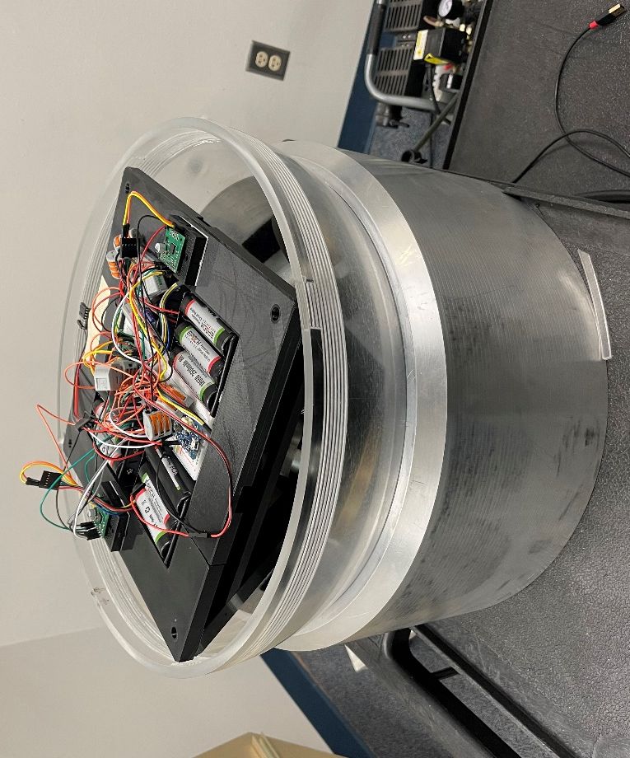
Internship realised at the United States Air Force Academy

SLT Clément AZPIROZ

Under the supervision of Lt Col Nathan Collins

Juin 2023
 |  | 

Déclaration d’intégrité relative au plagiat
Je certifie que :
- Je suis l’auteur du présent travail ;
- J’ai attribué et cité tout contenu emprunté selon les pratiques méthodologiques attendues.

Nom : AZPIROZ Prénom : Clément

Date : 12/06/2023 Signature :
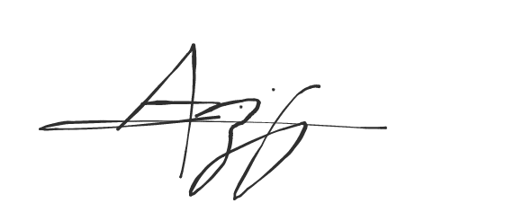

L'envoi par messagerie électronique à partir d'une adresse @ecole-air.fr et/ou le dépôt sur le site moodle.ecole-air.fr attestera de l'identité du signataire.

Table of contents
I Introduction 1
II General Information on ADCS 3
II-1 Presentation 3
II-2 Passive Stabilisation 3
II-2-1 Gravity gradient stabilisation 3
II-2-2 Spined satellites 3
II-2-3 Spined satellites with dualspin system 4
II-3 Active Stabilisation 4
II-3-1 Flywheel stabilisation 4
II-3-2 3 axis stabilization: satellites with reaction wheels 5
II-3-3 3 axis stabilization: satellites with gyroscopic actuators 5
II-4 Sensors 5
II-4-1 Optical sensors 5
II-4-2 Other sensors 6
III Air Bearing Table 7
III-1 Common Air Bearing Table structure 7
III-2 Air Bearing Table Design 7
III-2-1 The support subsystems 7
III-2-2 The actuator subsystem 10
III-2-3 The electronic subsystem 11
III-2-4 CAD Model of the assembly 13
IV Attitude Dynamics and Kinematics 15
IV-1 Dynamics 15
IV-1-1 Free Dynamics of satellite 15
IV-1-2 Dynamics of satellite with reaction wheels 15
IV-2 Kinematics 17
IV-2-1 Euler Angles 17
IV-2-1 Quaternions 18
IV-3 Digital Model 19
IV-3-1 Equation Model 19
IV-3-2 Physic model 21
V Control 23
V-1 Linear State Space Equations 23
V-2 Attitude Control 24
V-2-1 Opened Loop 24
V-2-2 Closed Loop 25
V-2-3 Disturbance 25
V-3 Open-loop Analysis 25
V-3-1 Stability Analysis 26
V-3-1 Precision Analysis 27
V-4 Closed-loop Analysis 27
V-5 Disturbance Analysis 30
VI Experiment 33
VI-1 Digital Model 33
VI-1-1 Equation Model 33
VI-1-2 Physic Model 34
VI-2 The Air Bearing Table 34
VI-3 The Simulink Command Program 36
VI-4 Digital Model Simulation 40
VI-4-1 Equation Model 40
VI-4-2 Physic Model 42
VI-5 Air Bearing Table Measures 44
VI-6 Comparison 46
VII Conclusion 49
References 51
Annex 53
Annex 1: Air bearing table component specifications 53
Annex 2: Matlab Workspace 57
Annex 3: Linearization of nonlinear MIMO (Multi Input Multi Output) model and state model 58
Annex 4: Laplace transform of a linear time-invariant (LTI) MIMO system 59
Annex 5: Matlab Function for control 60
Annex 6: Abacus 61
Annex 7: Characterization of DC motor with a gear ratio of 10:1 62

Résumé
Ce projet consiste à fournir, à l’US Air Force Academy, une table à coussin d’air expérimentale à 3 axes de liberté en rotation pour simuler le comportement de satellite en attitude dans un environnement sans frottement et d’étudier différents schémas de commande. Ainsi, une table a été développé puis imprimé grâce à une imprimante 3D après avoir abordé les connaissances générales sur la détermination d’attitude et les systèmes de contrôles des satellites. Le support de cette table est une sphère contenue dans une plateforme dans laquelle de l’air est éjecté sous pression pour réduire considérablement les frottements et les actionneurs sont des roues à réactions. Par la suite, les équations générales du mouvement sont déterminées afin de mettre en place des simulations sous Matlab Simulink à partir des équations d’une part et d’un modèle Simscape de l’autre. Ceci permet, par la suite, le design d’un schéma de commande adapté. Ainsi, une commande de type Proportionnelle Dérivé est étudiée et mise en place sur la table via une commande réalisée sous Matlab Simulink et implémenté via une carte Arduino MKR1000. Les simulations et des mesures sur la table sont réalisées afin de valider les modèles et le schéma de commande. Une solide base est ainsi fournie pour réaliser à l’avenir la future table qui servira à la création de travaux pratiques pour les cadets américains.

Abstract
This project aims to provide the US Air Force Academy an experimental 3-axis air bearing table to simulate satellite attitude behavior in a frictionless environment and study different control schemes. Accordingly, a table was developed and 3D printed after covering general knowledge about attitude determination and satellite control systems. The support for this table is a sphere contained within a platform where air is ejected under pressure to significantly reduce friction, and the actuators are reaction wheels. Subsequently, the general equations of motion are determined to set up simulations using Matlab Simulink based on equations and a Simscape model. This allows for the design of a suitable control scheme. Therefore, a Proportional Derivative (PD) control approach is studied and implemented on the table using a control system created with Matlab Simulink and implemented through an Arduino MKR1000 board. Simulations and measurements on the table are conducted to validate the models and the control scheme. A solid foundation is thus provided for the future development of a table that will be used for practical exercises for the American cadets.

Acknowledgments
I would like to express my gratitude to Lieutenant Colonel Nathan Collins and the entire Department of Astronautics (DFAS) for accompanying and advising me and providing the necessary tools for the completion of my end-of-studies internship.

Symbol List
Latin letters
$A$ state matrix
$A_{W}$ conversion matrix for the angular momentum of the reaction wheels
$B$ command matrix
$C$ output matrix
$D$ direct transmission matrix
$e$ unit vector coordinate
$g_{c}$ external disturbance torque
$h$ angular momentum
$I$ inertia matrix
$J$ inertia dyadic
$K$ gain matrix
$p$ Laplace variable
$q$ quaternion coordinate
$N_{e}$ external disturbance matrix
$N_{c}{, N}_{d}$ control torque matrix
$S$ cross product matrix
$x$ state vector
$y$ measurement state

Greek letters
$ω$ angular rate
$α, ϕ$ first rotation of Euler angles about the z axis
$β, θ$ second rotation of Euler angles about the x axis
$γ,ψ$ third rotation of Euler angles about the z axis
$Ω$ cross product matrix

I Introduction
Space exploration began with the technological advances of the Germans during the Second World War. It will know a considerable development during the Cold War and the famous "space race" between the United States and the USSR. Thus, scientific and technological progress has experienced and continues to experience significant growth in the fields of navigation, observation, telecommunications, imaging, meteorology. Space progress is also important on the military level (intelligence) and on the scientific level in order to understand the physical universe.
In order to achieve their goals, all these areas rely on the use of satellite. Indeed, since the first satellite launched by the USSR in 1957 (Sputnik 1), more than 11500 satellites have been placed in orbit, more than 1800 in 2022 and 6905 will be active in 2022 [1]. The skyrocketing of satellites since the beginning of the 2010's can be explained by the arrival in the space landscape of private actors such as SpaceX or emerging powers such as China. Thus, satellites are no longer only about state issues but also economic. Therefore, their studies and their development have become essential for the space and military industry.

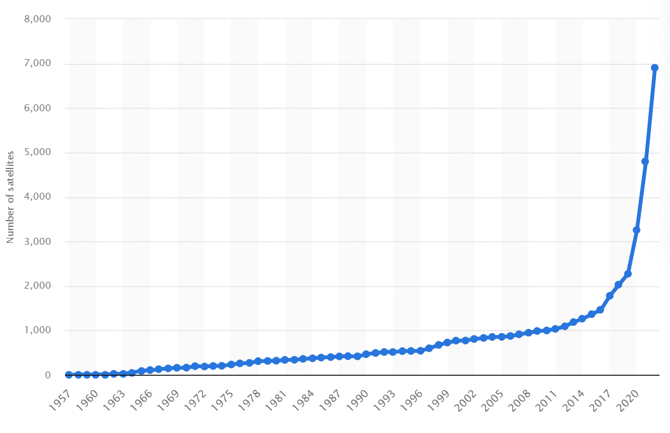
Fig 1 : Evolution of active satellites from 1957 to 2022 [1]

As part of the development of a mega-constellation of satellites to estimate the density of the atmosphere in real time, the United States Air Force Academy (USAFA) and the Department of Astronautics (DFAS) would like to develop an experimental air bearing table with 3 degrees of freedom of the rotational motion to simulate the attitude dynamic behavior of the object in a frictionless environment such as space and the system of command. This table is well suited to simulate and test control algorithms for these space vehicles. The project consists in improving a decade old air bearing table with modern hardware and software and to develop a digital version of the table under Matlab Simulink. The final aim of the project is to provide, to the USAF Cadets, a support to simulate and test new control algorithms for spacecrafts.

II General Information on ADCS

II-1 Presentation
The interest of satellites has been seen in the previous paragraphs. Let us now introduce the technical aspect of them.
A satellite is a free rigid system with 6 degrees of freedom (3 translations and 3 rotations). We generally separate the study of the movement around the center of mass of the satellite (attitude) and the movement of the center of mass (orbit). The control system of a satellite is then broken down into two parts: orbit control (subjecting the center of mass to describe a predefined orbit) and stabilization or attitude control (acquisition or maintenance of an operational attitude).
The attitude describes the orientation of the satellite with respect to an external reference. It evolves under the effect of external disturbances. The role of the ADCS (Attitude Determination and Control System) [2] is to evaluate and control the satellite's attitude, in the presence of these disturbances, by pointing the satellite's axes in the directions required for the mission. The satellite determines its attitude thanks to sensors and controls it thanks to actuators that generate motor torques. There are two principles of ADCS:
- passive ADCS: fundamental physical properties are exploited (gyroscopic stiffness, magnetic force, gravitational force).
- active ADCS: we detect the misalignments and we compensate them by corrective actions (torques).
The disturbances are numerous. They can be external: aerodynamic drag, solar radiation pressure, magnetic phenomena... They can also be internal: deformation of the structure, movement of external elements (antennas, panels), liquid ballast...

II-2 Passive Stabilisation

II-2-1 Gravity gradient stabilisation
We use the gravity gradient between the different points of the satellite to have a stable pointing of the satellite towards the direction of the center of the earth. The difference between the center of inertia and the center of gravity generates a tilting torque. To accentuate the phenomenon, masts are often deployed to create a stabilizing torque.

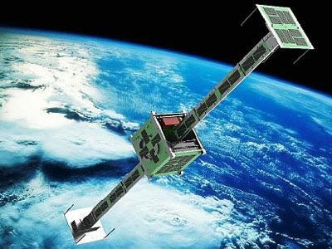
Fig 2: UniCubeSat-GG

II-2-2 Spined satellites
We use the stability properties of a rigid body in Euler motion.
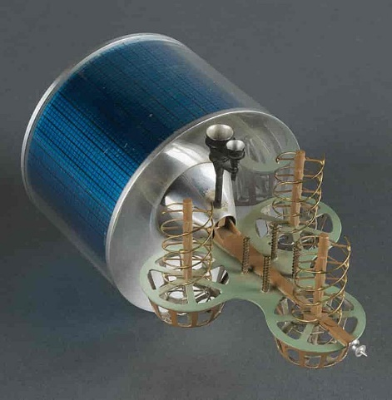
Fig 3: Marisat

II-2-3 Spined satellites with dualspin system
The mission given to a satellite does not always allow for a rotating payload (antenna pointing or imaging). It is therefore necessary to "despin" the part of the satellite containing the payload.
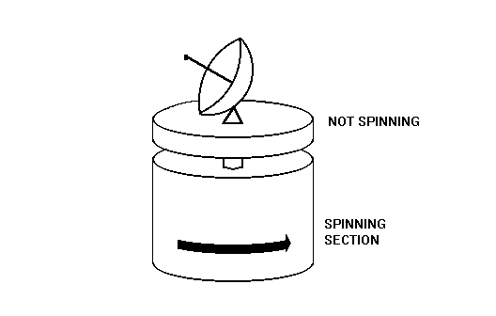
Fig 4: Scheme of a dualspin satellite

II-3 Active Stabilisation

II-3-1 Flywheel stabilisation
We use the stability properties of a wheel in rotation (20 000 rpm) around one of the three axis of the satellite (North-South axis). The satellite will thus be stable along the two others. For example, the wheel rotation axis can be the pitch axis and the stabilization will be on the roll and yaw axis. The control of the attitude around the pitch axis is done by varying the rotation speed of the wheel (creation of a reaction torque). Moreover, it is necessary to regularly "desaturate" the wheel (reaching the maximum or minimum speed) and to restore the attitude around the yaw and roll axes, thrusters or magneto couplers are then used.
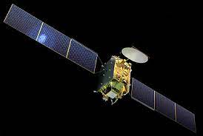
Fig 5: Eutelsat II

II-3-2 3 axis stabilization: satellites with reaction wheels
The control of the attitude around the three axes is done by variation of the rotation speed of three reaction wheels around the zero speed (creation of a reaction torque tending to counter the disturbing torques). Just like with the flywheel, it is necessary to regularly desaturate the wheels.
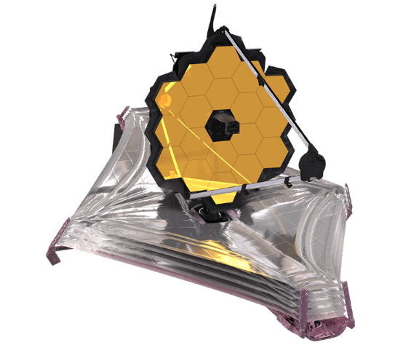
Fig 6: James Webb Space Telescope

II-3-3 3 axis stabilization: satellites with gyroscopic actuators
This type of stabilization is used for maneuvering satellites (need for fast attitude change, Key Hole spy satellites or Hubble) or for very high mass spacecraft (Mir or Skylab orbital station) because it allows to provide high torque. This assembly is based on three gyroscopes (1 axis) mounted along the three axes (roll, pitch and yaw). By tilting one of the gyroscopes with a servomotor, a gyroscopic torque is created which will tend to counteract the disturbing torques. We can also find assemblies based on several 2-axis gyroscopes or on 6 1-axis gyroscopes mounted head to tail.

II-4 Sensors

II-4-1 Optical sensors
There are three types of optical sensors such as the Earth sensors. They allow to give an orientation of the satellite along the roll and pitch axes. At this altitude, in the infrared band, the Earth appears as a hot disk on a cold background. The sensor allows to detect the variation of position of this hot disk and thus the orientation of the satellite with respect to the Earth. Moreover, the sun sensors allow to define the orientation of the satellite along the yaw axis or to acquire the attitude of the satellite. The principle is based on the use of silicon photocells and a system of windows (or slits). The inclination of the sun's rays is measured and consequently, the orientation of the satellite with respect to the sun is deduced. Other sensors are based on star tracking to provide the orientation of the satellite along the three axes.

II-4-2 Other sensors
Magnetometers are usable only at low altitude (less than 1000 km). We use the fact that the current flowing in a coil varies according to the magnetic field in which it is placed (earth magnetic field). A second sensor very used is the inertial sensors. We use gyroscopes (1 axis) or 2-axis gyroscopes. These sensors are reliable and can always measure the orientation of the vehicle but they are subject to drift. The combination of magnetometers and inertial sensors are called 9 DoF IMU (9 Degrees of Freedom Inertial Measurement) unit. Finally, the combination of inertial sensors and optical sensors gives a reliable and precise measurement system (precision of optical sensors and continuity of the use of inertial techniques).

III Air Bearing Table
The previous part draws a first approach concerning the space objects and their control system in attitude. From this knowledge, it is possible to conceive a first approach of the Air Bearing Table.

III-1 Common Air Bearing Table structure
Since the beginning of the space race, 50 years ago, air bearing table have been used to simulate, test and verify embedded hardware and software. This system provides a three-axis angular movement in a frictionless environment, similar to outer space. However, this idealization is not valid because of many disturbance torques on the system. Indeed, drag, bearing friction and gravity center offset are the major source of disturbance torques and must be modeled in order to validate the simulations. Moreover, this disturbances must be minimized until becoming compatible with the torque normally found in the space environment, ensuring the validity of simulators [3]. In order to reduce this disturbances, especially bearing friction, the air bearing operates by levitating the system with air pressure. Therefore, solid contact between the body and the support is significantly reduced, creating a relatively frictionless environment for attitude dynamics [4].
In order to understand how to make an air bearing table, we need to understand how a satellite is controlled. Previously, we have seen the different stabilization and control but we need now to mention the pros and cons of each method of control.
Many satellite missions employ gravity gradient stabilization or only magnetic control technique to control the attitude because they are simple and require a minimum coast. Nevertheless, they can only provide low pointing accuracies and limited attitude command. This is why we can use reaction wheels. They are costly but effective and now use for small and large satellites. Almost all satellites missions with reaction wheels as attitude actuators proved that a high attitude control performance can be achieved and satisfy the mission requirements [5]. It is common to equip the satellite with three or four reaction wheels. However, it is important to mention the reaction wheel saturation issue due to the constant external disturbance torques (such as gravity center offset for an air bearing table). Therefore, satellites are commonly equipped with a momentum management scheme or with another external torque source such as thrusters or magnetic torquers in order to remove its excess wheel momentum. But magnetic torquers are more preferred as they are cheaper compared to the thrusters that consume large amount of fuel or gaz.
To finish, let talk about the embedded electronic components. An air bearing table is generally composed of an IMU sensor to provide the position, angular rate and speed. Then, a processor is needed to process the measurement and determine the command to the actuator. A wireless components could be required if the processor need an external connection (to a computer for example). Of course, the system requires a power source to supply all the electronic components and actuators. It could be batteries for example. To conclude, all the architecture is made in this way to have an autonomous system without an external power or connection, avoiding an external disturbance torque on the system and providing a very well balanced system.

III-2 Air Bearing Table Design

III-2-1 The support subsystems
First, let consider the first elements of air bearing table: the platform.

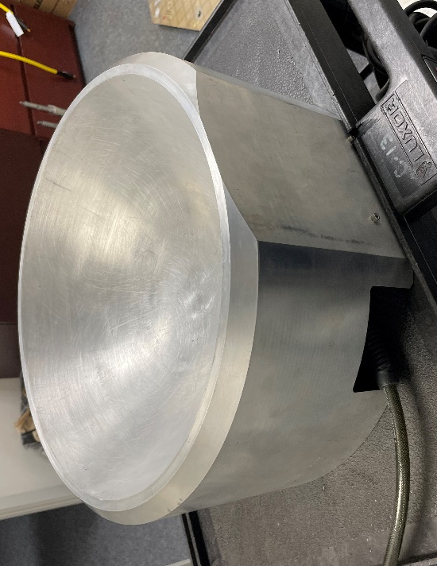
Fig 7: The platform of the air bearing table

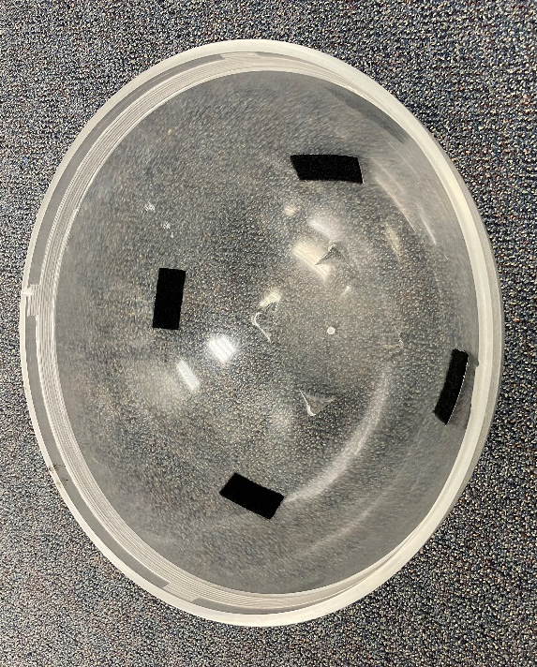
Fig 8: The hemispherical support

We have here the platform (Fig 7) which is hemispherical to welcome the hemispherical support (Fig 8). In this case, the system will be limited to three-axis angular movement Moreover, there are a compressed air inlet to ensure the frictionless movement. The air is supplied by a compressor and a pipe:

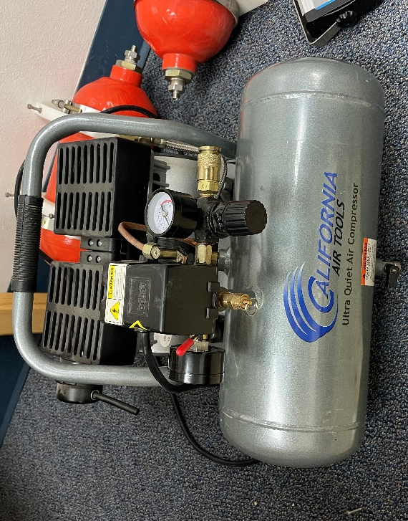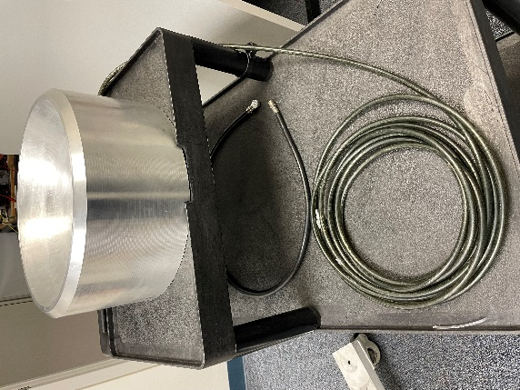
Fig: The air compressor and the pipe

With this system, the support will not be in direct contact with the platform and the near frictionless environment will be provide. Indeed, there are plenty of little holes for the air outlet as shown in the next figure:

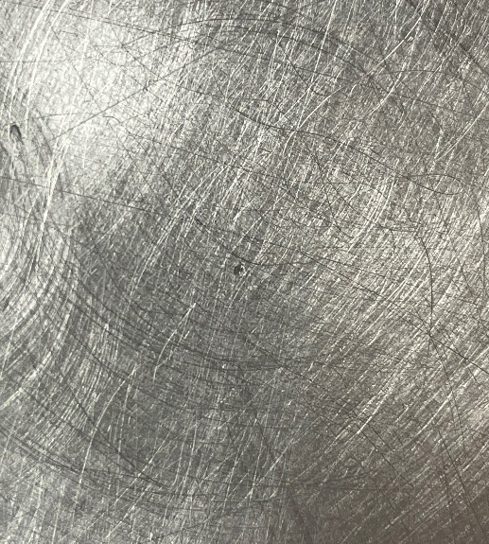
Fig 9: Air outlet

Therefore, the platform and support assembly are:

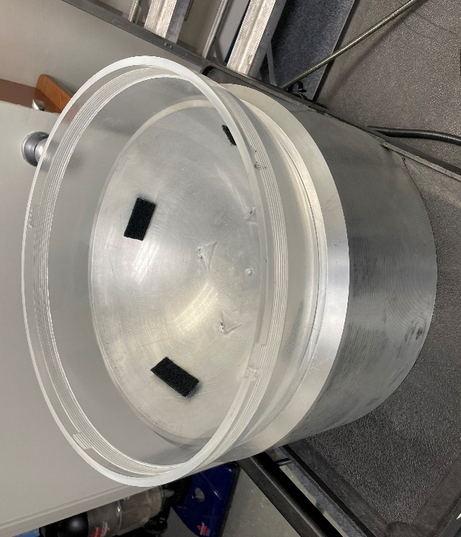
Fig 10: The platform and support assembly

Then, we have to design the carrier to welcome all the actuator and electronic subsystems. This part will be design on Autodesk Fusion 360, a CAD software, in order to have a relevant design. As we can see in the Fig 10, there are four notches inside the hemisphere. Il will be the base of the carrier:

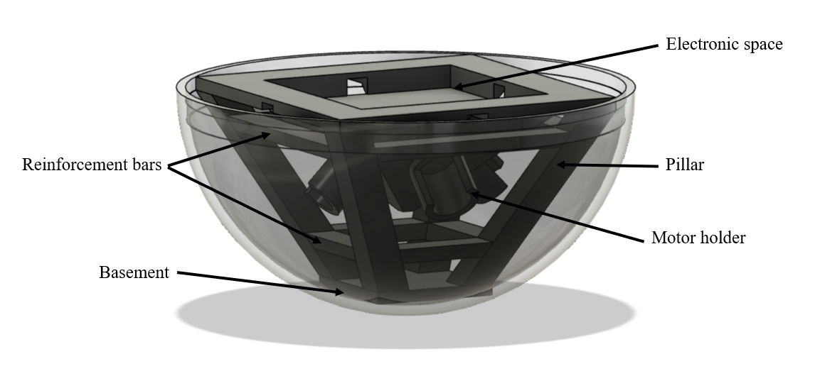
Fig 11: The CAD model of the carrier

From the basement, the four pillars are supporting the electronic space. This space is composed of an area of 2cm deep to welcome all the electronic components and four holes for cable managements. The area in depth is important to keep the IMU sensor as close as possible from the center of rotation. Moreover, there are also eight reinforcement bars to stiffen the whole. Then, a motor holder consists in inserting the motor and maintain it with a collar. The cylinder is opened for power cable and to ensure the flexibility in order to tighten the motor.

III-2-2 The actuator subsystem
We choose to have four motors for four reaction wheels. Indeed, there is a plenty of reaction wheel architecture with three or four wheels. This one is the most common because each reaction wheel contributes to two rotation axis. Thus, the control system will be redundant. For example, if a wheel does not work, the three other ones can still command the three rotations. The four motors will be Pololu 10:1 Metal Gearmotor 37D 12V (Brushed Motor) with four wheels such as the figure below:

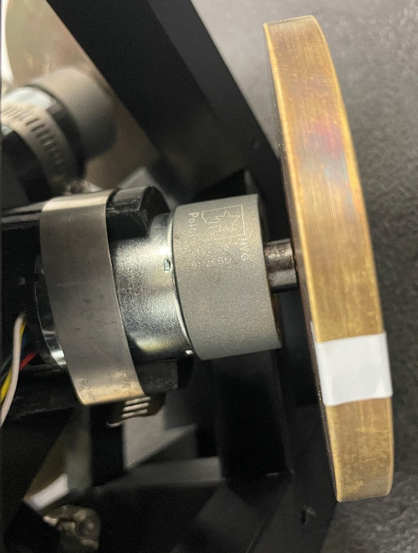
Fig 12: Motor and wheel

III-2-3 The electronic subsystem
Now, it is important to describe all the electronic components of the air bearing table needed to sense, process and drive the actuator subsystem. First, let talk about the processor: it will be an Arduino board and more precisely an MKR 1000 WIFI (Fig 13). Indeed, this Arduino board is compatible to Simulink, powerful and Wi-Fi controllable to avoid having a cable leaving the system and disturbing the balance.

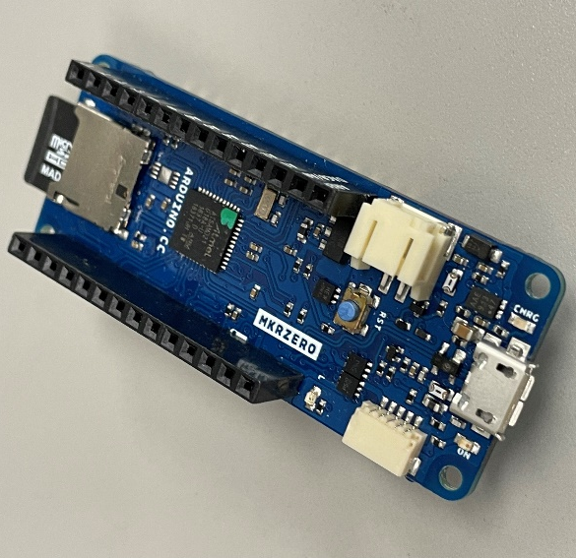
Fig 13: Arduino MKR 1000 WIFI

Then, the IMU sensor will be a SparkFun 9DoF IMU (ICM-20948, Fig 14) because it is compatible with Simulink. However, it is not providing the quaternion directly but just the angular rates. We will have to do a conversion from angular rates to quaternion.

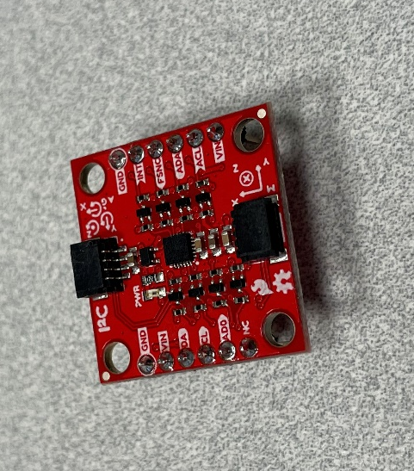
Fig 14: SparkFun 9Dof IMU (ICM-20948)

We have now the sensor and the processor but we need the power chain and the driver. The electric energy will be supplied by four battery (one for each motor). One of the four will also be used to supply the Arduino board. One battery (Fig 15) is composed of three 12V li-ion batteries of 2600 mAh in series. However, the MKR1000 need to be supply by 5V. So, we will use a 12V-5V Convertor (Fig 16).

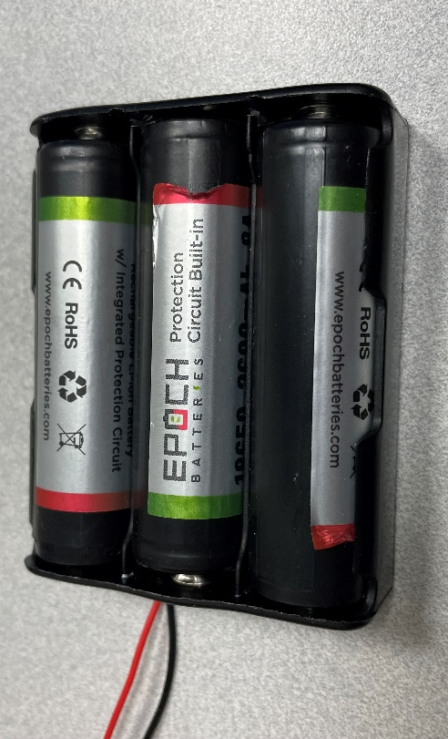
Fig 15: Battery

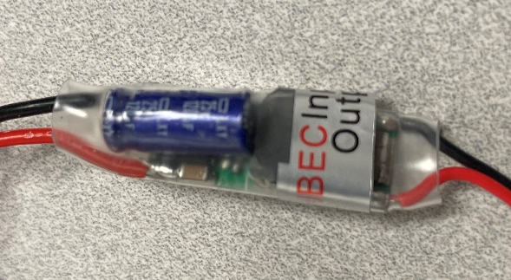
Fig 16: 12V-5V Convertor

Finally, we need motor drivers to command the motor with an input signal. We will use four TB9051FTG Single Brushed DC Motor Driver (Fig 17). This driver is taking an input PWM (Pulse Width Modulation) Signal and an input power and provide an output modulated power signal.

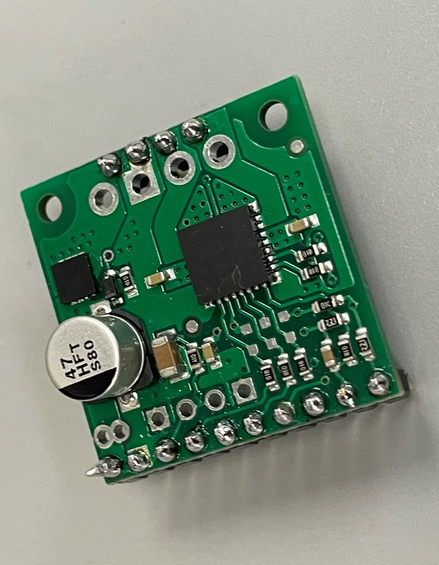
Fig 17: TB9051FTG Single Brushed DC Motor Driver

III-2-4 CAD Model of the assembly
We have now all the components of the air bearing table. We can now provide a first view of the components positioning on the table.

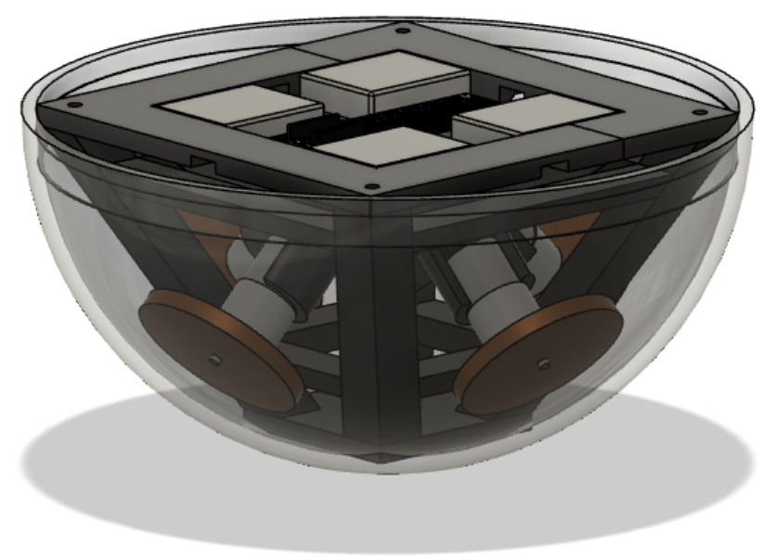
Fig 18: CAD Model of the Air Bearing Table

The Figure 18 provide us the CAD model with all the actuators and electronic components and the Figures 19 and 20 show a more precious look on different parts.

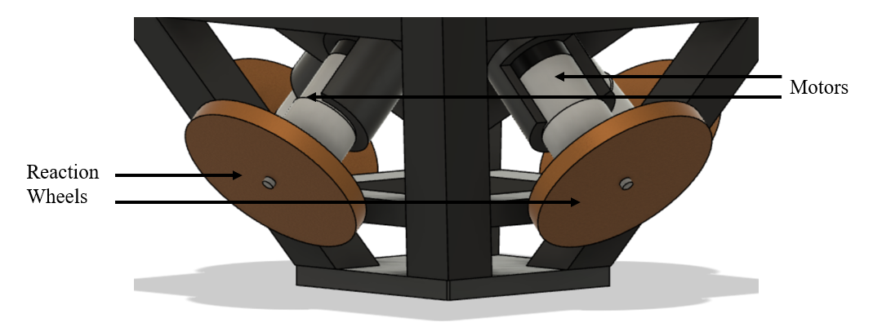
Fig 19: Actuator Assembly

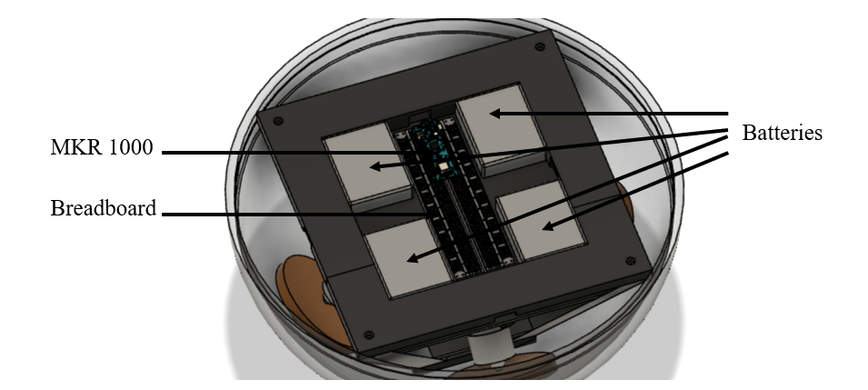
Fig 20: Electronic Assembly

The architecture of the air bearing table is made to keep it as balanced as possible. This is one of the reasons we have one battery by motor and then place it at each corner. In that way, all the system has a symmetry according to the planes ($\vec{x},\vec{z}$) and ($\vec{y},\vec{z}$). However, we can’t keep this perfect symmetry because of the electronic components. Indeed, the breadboard is place at the center but along the $\vec{x}$ or $\vec{y}$ axis and some of the motor drivers will be placed between the batteries. Indeed, all the electronic components can not fit into the main breadboard and the IMU sensor have to be as closed as possible of the origin (or the center of rotation).
To finish, the carrier is divided into several parts because the carrier does not fit in the 3D printer. Moreover, the printing quality will be better with small parts.

With a complete CAD Model, Fusion 360 provides the specifications and the inertia matrix of the whole air bearing table (electronic components are negligible in front of the sphere and carrier mass):
$$Mass=7.682 kg$$
$$Bounding Box=0.4×0.4×0.2 m$$
$$I≈\left[\begin{matrix}0.143 & 0 & 0 \\ 0 & 0.143 & 0 \\ 0 & 0 & 0.129\end{matrix}\right]kg.m^{2}$$
Specifications of every air bearing table components are available in Annex 1.

IV Attitude Dynamics and Kinematics
We have seen previously the structure and the different component on the air bearing table. Now, it is time to define the dynamics and kinematics equation of motion. Indeed, we need this equations to be able to build a digital model of the table, analyze the table behavior and define and test a control algorithm.
All the following equation developments are made for satellites with 3 degrees of freedom. However, they are also applicable to the air bearing table because we will consider that it evolves in a frictionless environment (no drag and no bearing friction) and the table is perfectly balanced.

IV-1 Dynamics

IV-1-1 Free Dynamics of satellite
First, we will consider the dynamics of a free satellite.
A Euler motion of a body is a rotational movement around a fix point of the body (air bearing table) or around his center of inertia, fix or moving (satellite). So, the following equation, called Euler’s Moment Equation (or Coriolis), is applicable to the satellite and the air bearing table:
$$\frac{d}{dt}{(\vec{h_{c}})}_{B}+\vec{ω_{B/A}}×\vec{h_{c}}=\vec{g_{c}}$$
Where $\vec{h_{c}}$ is the total angular momentum for the system, $\vec{g_{c}}$ is the external disturbance torque, B is the body frame and A is the inertial frame [6].
We get the total angular momentum for the system about its center of mass by the momentum of the spacecraft.
$$\vec{h_{c}}=\vec{J}.\vec{ω_{B/A}}$$
Where $\vec{J}$ is the inertia dyadic about the spacecraft’s center of mass. Applying this expression to the Euler’s Moment Equation gives us:
$$\vec{J}.\frac{d}{dt}{(\vec{ω_{B/A}})}_{B}+\vec{ω_{B/A}}×\vec{J}.\vec{ω_{B/A}}=\vec{g_{c}}$$
The previous equation in matrix form gives us:
$$I_{B}.\frac{d}{dt}{([ω_{B/A}]}_{B})+{[ω_{B/A}]}_{B}×I_{B}.{[ω_{B/A}]}_{B}={[g_{c}]}_{B}$$
Where $I_{B}$ is the inertia matrix about the spacecraft’s center of mass [7].

IV-1-2 Dynamics of satellite with reaction wheels
Then, we will reconsider the previous equations with 3 reaction wheels. Now, the system is composed of the body satellite and 3 reaction wheels which each wheels is positioned along one axis of the body frame B. First, let’s start to define the expression of the angular momentum of every wheels:
$$\vec{h_{W}}=\vec{J_{W}}.\vec{ω_{W/A}}$$
Where $\vec{J_{W}}$ is the inertia dyadic of the wheel. The wheel’s angular velocity can be defined with respect to either the inertial frame or the body axis body frame. Since its spin axis is fixed with respect to the body frame, its angular velocity with respect to the body is its spin rate magnitude times its direction:
$$\vec{ω_{W/A}}= \vec{ω_{W/B}}+\vec{ω_{B/A}}$$
Or
$$\vec{ω_{W/A}}=ω_{s}\vec{s}+\vec{ω_{B/A}}$$
Because the wheel is constrained to rotate only in the $\vec{s}$ direction. Applying to our expression for the wheel’s angular momentum [7]:
$$\vec{h_{W}}=\vec{J_{W}}.ω_{s}\vec{s}+\vec{J_{W}}.\vec{ω_{B/A}}$$
Therefore, for each wheel, we have:
$$\vec{h_{W1}}=\vec{J_{W1}}.ω_{s1}\vec{s_{1}}+\vec{J_{W1}}.\vec{ω_{B/A}}$$
$$\vec{h_{W2}}=\vec{J_{W2}}.ω_{s2}\vec{s_{2}}+\vec{J_{W2}}.\vec{ω_{B/A}}$$
$$\vec{h_{W3}}=\vec{J_{W3}}.ω_{s3}\vec{s_{3}}+\vec{J_{W3}}.\vec{ω_{B/A}}$$
$$\vec{h_{W4}}=\vec{J_{W4}}.ω_{s4}\vec{s_{4}}+\vec{J_{W4}}.\vec{ω_{B/A}}$$
Where:
$$\vec{s_{1}}=\frac{\sqrt{2}}{2}\vec{y}-\frac{\sqrt{2}}{2}\vec{z}$$
$$\vec{s_{2}}=-\frac{\sqrt{2}}{2}\vec{x}-\frac{\sqrt{2}}{2}\vec{z}$$
$$\vec{s_{3}}=-\frac{\sqrt{2}}{2}\vec{y}-\frac{\sqrt{2}}{2}\vec{z}$$
$$\vec{s_{4}}=\frac{\sqrt{2}}{2}\vec{x}-\frac{\sqrt{2}}{2}\vec{z}$$

The Euler’s Moment Equation is still applicable to both the satellite and the air bearing table with the reaction wheels and we have again:
$$\frac{d}{dt}{(\vec{h_{c}})}_{B}+\vec{ω_{B/A}}×\vec{h_{c}}=\vec{g_{c}}$$
But the total angular momentum for the system with the contribution of the spinning wheels is now:
$$\vec{h_{c}}=\vec{J}.\vec{ω_{B/A}}+\vec{J_{W1}}.ω_{s1}\vec{s_{1}}+\vec{J_{W2}}.ω_{s2}\vec{s_{2}}+\vec{J_{W3}}.ω_{s3}\vec{s_{3}}+\vec{J_{W4}}.ω_{s4}\vec{s_{4}}$$
Or:
$$\vec{h_{c}}=\vec{J}.\vec{ω_{B/A}}+\vec{h_{Wx}}+\vec{h_{Wy}}+\vec{h_{Wz}}$$
Where $\vec{h_{Wx}}, \vec{h_{Wy}},\vec{h_{Wz}}$ is the angular momentums created by the reaction wheels along the axis of the body frame and $\vec{J}$ is the inertia dyadic od the body-wheel combination about the spacecraft’s center of mass. Applying this expression to the Euler’s Moment Equation gives us:
$$\vec{J}.\frac{d}{dt}{(\vec{ω_{B/A}})}_{B}+\frac{d}{dt}{(\vec{h_{Wx}})}_{B}+\frac{d}{dt}{(\vec{h_{Wy}})}_{B}+\frac{d}{dt}{(\vec{h_{Wz}})}_{B}+\vec{ω_{B/A}}×\left(\vec{J}.\vec{ω_{B/A}}+\vec{h_{Wx}}+\vec{h_{Wy}}+\vec{h_{Wz}}\right)=\vec{g_{c}}$$
We can write this expression in a matrix form:
$$I_{B}.\frac{d}{dt}{\left(\left[ω_{B/A}\right]\right)}_{B}+\frac{d}{dt}{\left(\left[h_{W}\right]\right)}_{B}+{\left[ω_{B/A}\right]}_{B}×\left(I_{B}.{\left[ω_{B/A}\right]}_{B}+{\left[h_{W}\right]}_{B}\right)={[N_{e}]}_{B}$$
Where $I_{B}$ is the inertia matrix about the spacecraft’s center of mass, $\left[h_{W}\right]$=$\left.\begin{matrix}h_{Wx} \\ h_{Wy} \\ h_{Wz}\end{matrix}\right.$ and
$\left[ω_{B/A}\right]=\begin{matrix}ω_{x} \\ ω_{y} \\ ω_{z}\end{matrix}$.
Therefore:
$$\frac{d}{dt}{\left(\left[ω_{B/A}\right]\right)}_{B}={{I_{B}}^{-1}[N_{e}]}_{B}-{I_{B}}^{-1}S\left(ω\right)I_{B}{\left[ω_{B/A}\right]}_{B}-{I_{B}}^{-1}S\left(ω\right){\left[h_{W}\right]}_{B}-{I_{B}}^{-1}\frac{d}{dt}{\left(\left[h_{W}\right]\right)}_{B}$$
Where writing the cross product as a matrix operation using S() makes the notation simpler:
$$S\left(ω\right)=\left[\begin{matrix}0 & {-ω}_{z} & ω_{y} \\ ω_{z} & 0 & {-ω}_{x} \\ {-ω}_{y} & ω_{x} & 0\end{matrix}\right]$$
Moreover, the combined dynamic model of the system is completed by noting that control torque in the body coordinate is $N_{c}$ and gives the rate of change of the total angular momentum from wheels:
$$\left[h_{W}\right]=-[N_{c}]$$
And so:
$$\frac{d}{dt}\left(\left[ω_{B/A}\right]\right)={I_{B}}^{-1}\left[N_{e}\right]-{I_{B}}^{-1}S\left(ω\right)I_{B}\left[ω_{B/A}\right]-{I_{B}}^{-1}S\left(ω\right)\left[h_{W}\right]+{I_{B}}^{-1}\left[N_{c}\right] [5]$$

In this case, the wheel is not aligned with an axis of the body frame, the shaft axis of the wheel is rotated with respect to the body frame. The angular momentum vector of the wheel seen from the satellite is then needed, using a rotation from wheel coordinates to body frame and the components of this angular momentum in the body system coordinates system is a projection of the wheel’s angular momentum along its axis of rotation. The reaction wheel assembly consists of four wheels and we have the directional cosines for each wheel in the columns of the direction matrix for the wheels:
$$\left[\begin{matrix}h_{Wx} \\ h_{Wy} \\ h_{Wz}\end{matrix}\right]=\left[\begin{matrix}0 & -\frac{\sqrt{2}}{2} & 0 & \frac{\sqrt{2}}{2} \\ \frac{\sqrt{2}}{2} & 0 & -\frac{\sqrt{2}}{2} & 0 \\ -\frac{\sqrt{2}}{2} & -\frac{\sqrt{2}}{2} & -\frac{\sqrt{2}}{2} & -\frac{\sqrt{2}}{2}\end{matrix}\right]\left[\begin{matrix}h_{1} \\ h_{2} \\ h_{3} \\ h_{4}\end{matrix}\right]$$
Or:
$$\left[h_{W}\right]=\left[A_{W}\right]\left[h\right] [5]$$

IV-2 Kinematics
The equations of motions have been seen previously. Now we need the tools to describe the position of a system: that is kinematic. In order to describe the attitude, we can use two parameters: Euler’s angle or quaternions.

IV-2-1 Euler Angles
The first one is the most frequently used for attitude parameters. Indeed, it is very intuitive to visualize the different angle just as show below:

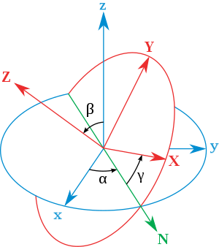
Fig 21: Euler Angles [8]

However, using the Euler angles, we need to provide a sequence of rotation according to each axis in order to describe a rotation. With 3 axis, we have 12 valid sets of Euler angles. For example, the following equation shows the kinematic equation for the Euler angles (Z→Y→X):
$$\left[\dot{\begin{matrix}Φ \\ \dot{θ} \\ \dot{ψ}\end{matrix}}\right]=\frac{1}{\cos{θ}}\left[\begin{matrix}\cos{θ} & \sin{Φ}\sin{θ} & \cos{Φ}\sin{θ} \\ 0 & \cos{Φ}\cos{θ} & -\sin{Φ}\cos{θ} \\ 0 & \sin{Φ} & \cos{Φ}\end{matrix}\right]\left[\begin{matrix}ω_{x} \\ ω_{y} \\ ω_{z}\end{matrix}\right]$$
This equation is worth a closer look. First, the right hand side of the equation has $\cos{θ}$ in the denominator. For $θ=∓90°$, this equation is not valid. Therefore, it is evident that the Z→Y→X Euler angles fail to describe the change in attitude of the body frame at $θ=∓90°$. This inability of the Euler angles appears in the kinematic equation. In mathematics, this attitude is called a singular point. On the other hands, the first rotation angle $ψ$ does not appear on the right side of the equation. We can find the other two angles $Φ$ and $θ$, but not $ψ$ [8].

IV-2-1 Quaternions
The second parameters are the quaternions. They are used as widely as the Euler angles. The quaternions consist of four parameters, while the Euler angles have three. Then why do we bother employing the quaternions when we have the Euler angles, which require a fewer number of parameters. First, the quaternions never fail to describe the attitude while it is the case for Euler angles, as explained before. For the quaternions, this never happens because we have one more parameter. Second, the quaternions do not require any form of trigonometric in the attitude description. The trigonometric functions require a large number of computational resources for evaluation.
In spite of all these advantages, the quaternions are used less frequently than the Euler angles. This is because their physical meaning is not readily noticeable through intuition. While we can make a rough sketch of the attitude from the Euler angles, we cannot do so from quaternions. Although not as intuitively noticeable as the Euler angles, the quaternions also have a physical meaning.
The quaternions are based on the identification of the axis and the angle of rotation about the Euler’s eigenaxis. They are defined as the following equation:
$$q_{1}=e_{1}\sin{\frac{θ}{2}}$$
$$q_{2}=e_{2}\sin{\frac{θ}{2}}$$
$$q_{3}=e_{3}\sin{\frac{θ}{2}}$$
$$q_{4}=\cos{\frac{θ}{2}}$$
Where $θ$ denotes the rotation angle, ($e_{1}, e_{2}, e_{3}$) are the components of the unit vector along the eigenaxis and these three values satisfy ${e_{1}}^{2}+{e_{2}}^{2}+{e_{3}}^{2}=1$. There is only one set of quaternions for a given attitude. This is different from the Euler angles, which have 12 valid sets of parameters. Moreover, the quaternions are based on a single rotation and have no other choice in terms of rotation sequence [8].
The kinematic equation for the equation is:
$$\left[\begin{matrix}\dot{q_{1}} \\ \dot{q_{2}} \\ \dot{q_{3}} \\ \dot{q_{4}}\end{matrix}\right]=\frac{1}{2}\left[\begin{matrix}0 & ω_{z} & -ω_{y} & ω_{x} \\ {-ω}_{z} & 0 & ω_{x} & ω_{y} \\ ω_{y} & -ω_{x} & 0 & ω_{z} \\ {-ω}_{x} & -ω_{y} & -ω_{z} & 0\end{matrix}\right]\left[\begin{matrix}q_{1} \\ q_{2} \\ q_{3} \\ q_{4}\end{matrix}\right]$$
Or in a compact notation:
$$\dot{q}=\frac{1}{2}Ω\left(ω\right)q$$

IV-3 Digital Model
The dynamic and kinematic equations are now known. In order to simulate and test a control scheme, we need to develop a digital model of the system. The Matlab environment and more precisely the Simulink Add-on will be use. Indeed, this software deals with matrix and Simulink with block diagram. Moreover, there are plenty of automatic and control add-ons to study for model and control analysis.

IV-3-1 Equation Model
The first way to build a digital model is to use the equations seen above:
$$\frac{d}{dt}\left(\left[ω_{B/A}\right]\right)={I_{B}}^{-1}\left[N_{e}\right]-{I_{B}}^{-1}S\left(ω\right)I_{B}\left[ω_{B/A}\right]-{I_{B}}^{-1}S\left(ω\right)\left[h_{W}\right]+{I_{B}}^{-1}\left[N_{c}\right]$$

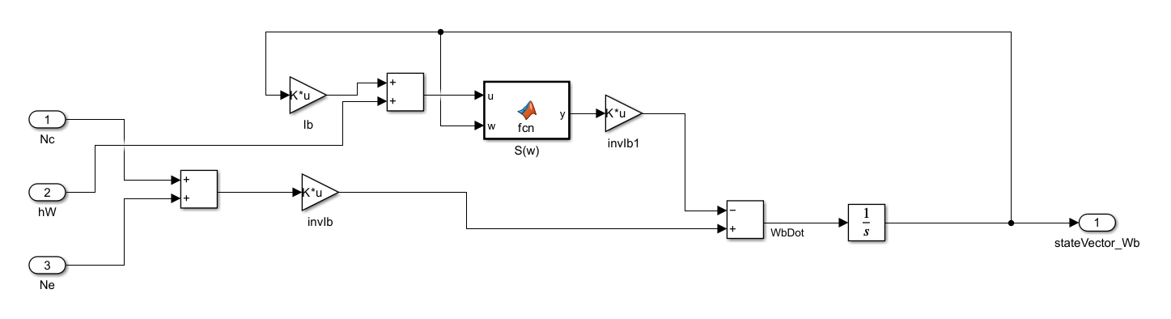
Fig 22: Simulink model for the dynamic equation

The inputs are the angular momentum of the reaction wheels, the reaction wheel torques and the disturbance torques and the output is the angular rate of the system.
Then, the kinematic equation is also modelized:

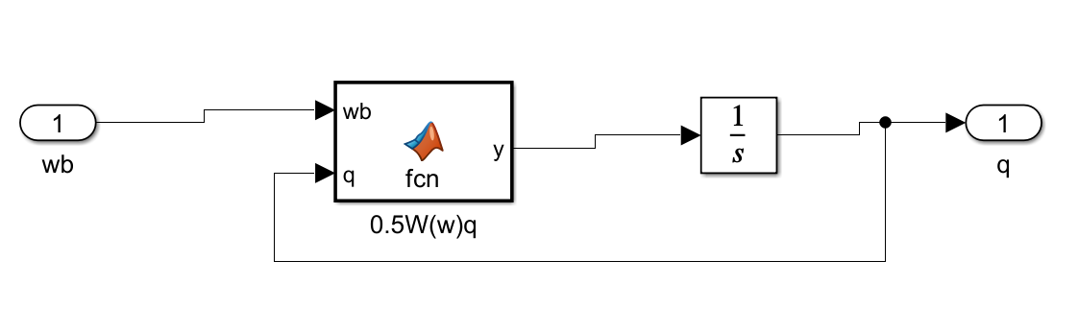
Fig 23: Simulink model for the kinematic equation
This subsystem provides the quaternion from the angular rate of the table.
To finish with the equation blocks, we have to build the last simulation model which is for the reaction wheels:

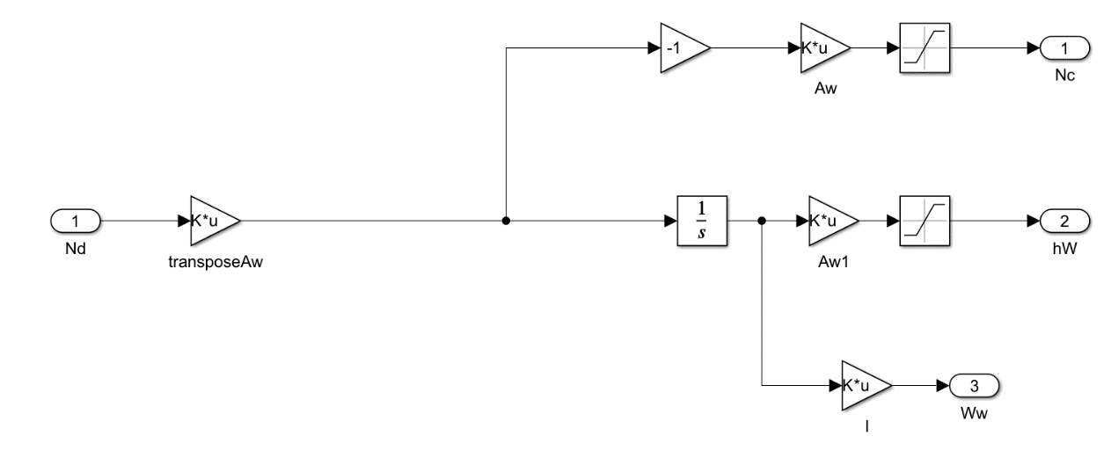
Fig 24: Simulink model for the reaction wheels

This model represents some perfect idealized reaction wheels (the motors can accelerate as fast as demanded). The input is the torque providing by the control and the outputs are the reaction wheel torques and the angular momentum of the wheels for the dynamic model. The third output is the angular rate of each reaction wheels to monitor these speeds during the simulation. Moreover, saturations are implanted because the motors are limited in torque and speed. The reaction wheels dynamic is not integrated directly to the dynamic equation because, if the dynamics are clearly separated, it is easier to change the number and the configuration of the reaction wheels. Indeed, in the previous model, we just have to change the matrix $A_{W}$ and I.
Therefore, the complete Simulink model from the equations is as follow:

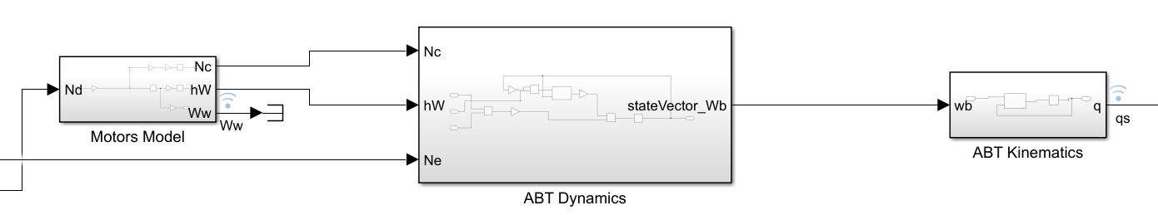
Fig 25: Complete Simulink model of the dynamic and kinematic equations

IV-3-2 Physic model
However, it is still possible to build a digital model without knowing the dynamic and kinematic equations by using a Simscape model. Indeed, it is a Simulink feature that uses physical component models based on physical connections and directly integrated with block diagrams and other paradigms.

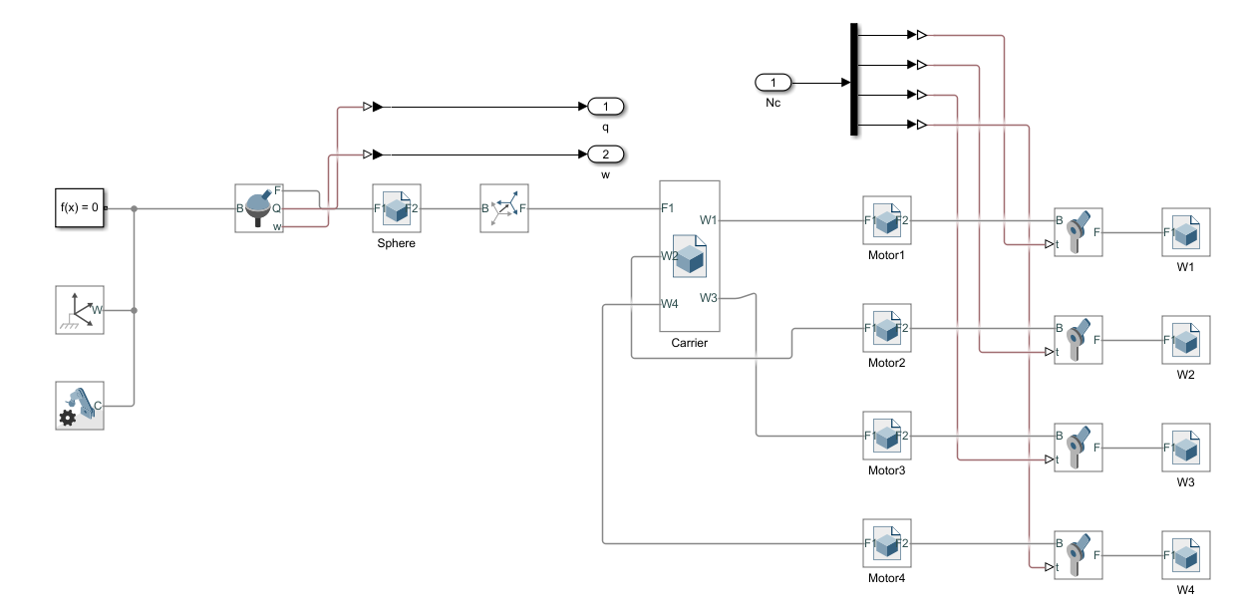

Fig 26: Simscape model of the air bearing table

The model is composed of body (carrier, sphere, motors), joints and frames. The inputs are the command torques for the motors and the output are the quaternions and the angular rate of the table. One of the benefits is that Simscape provides a 3D animation over time of the table:

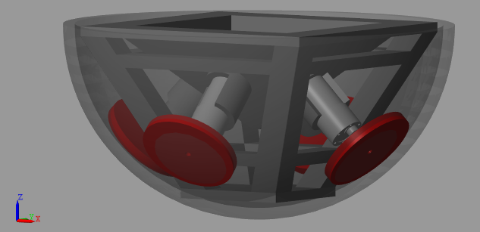
Fig 27: Simscape 3D Animation of the system

Some Simulink models are using Matlab function in order to realize some complex matrix calculations. Moreover, the models call some matrix in the workspace (available in Annex 2).

V Control

V-1 Linear State Space Equations
In order to analyze and determine the performances of a control design in precision, stability and speed, we need to linearize the state equation of the system (Annex 3 and 4).
The point of operation will be $(\overline{ω}, \overline{q}, \overline{h_{c}})$ to linearize the nonlinear equation of motion and to have a linear state space equation [8]. The deviation from the steady state is denoted by $ω=\overline{ω}+\tilde{ω}$. Now, let’s linearized the quaternion. With $dq$ denoting the orientation at time $t+dt$ relative to the attitude at time $t$:
$$\left[\begin{matrix}\tilde{q}\end{matrix}\right]=\left[\begin{matrix}{dq}_{1} \\ {dq}_{2} \\ {dq}_{3} \\ {dq}_{4}\end{matrix}\right]=\left[\begin{matrix}e_{1}\sin\left(\frac{1}{2}ωdt\right) \\ e_{2}\sin\left(\frac{1}{2}ωdt\right) \\ e_{3}\sin\left(\frac{1}{2}ωdt\right) \\ \cos\left(\frac{1}{2}ωdt\right)\end{matrix}\right]≃\left[\begin{matrix}\frac{1}{2}ω_{x}dt \\ \frac{1}{2}ω_{y}dt \\ \frac{1}{2}ω_{z}dt \\ 1\end{matrix}\right]$$
So, $\frac{d}{dt}q_{4}=0$ and:
$$\frac{d}{dt}\left[\begin{matrix}\tilde{q_{1}} \\ \tilde{q_{2}} \\ \tilde{q_{3}}\end{matrix}\right]=\frac{1}{2}I_{3×3}ω [6]$$

$h=\overline{h}+\tilde{h}$ and $\frac{d}{dt}h=\frac{d}{dt}\tilde{h}$
The form of the linear equation of motion has a state vector:
$$x={(\tilde{ω_{x}}, \tilde{ω_{y}},\tilde{ω_{z}},\tilde{q_{1},}\tilde{q_{2},}\tilde{q_{3},}h_{Wx},h_{Wy},h_{Wz})}^{T}$$
And has control input $u=N_{c}$. The state space equation is then:
$$\dot{x}\left(t\right)=A\left(t\right)x\left(t\right)+B_{u}\left(t\right)N_{c}\left(t\right)+B_{d}\left(t\right)N_{e}(t)$$
Where $B_{d}\left(t\right)$ is the command matrix for the disturbances.
With the external torque and disturbance torque have zero mean and where:
$$A_{ij}=\frac{∂f_{i}}{∂x_{j}}; B_{ij}=\frac{∂f_{i}}{∂u_{j}}$$
And:
$$f=\left[\begin{matrix}{I_{B}}^{-1}N_{e}-{I_{B}}^{-1}S\left(ω\right)I_{B}ω-{I_{B}}^{-1}S\left(ω\right)h+{I_{B}}^{-1}N_{c} \\ -\frac{1}{2}S\left(ω\right)\left[\begin{matrix}q_{1} \\ q_{2} \\ q_{3}\end{matrix}\right]+\frac{1}{2}q_{4}I_{3×3}ω \\ -\frac{1}{2}ω^{T}\left[\begin{matrix}q_{1} \\ q_{2} \\ q_{3}\end{matrix}\right] \\ -N_{c}\end{matrix}\right]$$
By calculating the Jacobians, we have:
$$A=\left[\begin{matrix}{I_{B}}^{-1}A_{ω,ω} & 0 & A_{ω,h} \\ \frac{1}{2}I_{3×3} & 0 & 0 \\ 0 & 0 & 0\end{matrix}\right]$$
$$B_{u}=\left[\begin{matrix}{I_{B}}^{-1} \\ 0 \\ {-I}_{3×3}\end{matrix}\right]; B_{d}=\left[\begin{matrix}{I_{B}}^{-1} \\ 0 \\ 0\end{matrix}\right]$$
With:
$$A_{ω,ω}=\left[\begin{matrix}ω_{y}I_{b,31}-ω_{z}I_{b,21} & I_{b,31}ω_{x}+{2ω}_{y}I_{b,32}+I_{b,33}ω_{z}-ω_{z}I_{b,22}-h_{Wz} \\ -2I_{b,31}ω_{x}-I_{b,32}ω_{y}-ω_{z}I_{b,33}+ω_{z}I_{b,11}+h_{Wz} & ω_{z}I_{b,12}-ω_{x}I_{b,32} \\ I_{b,21}ω_{x}+ω_{y}I_{b,22}+I_{b,23}ω_{z}-ω_{y}I_{b,11}-h_{Wy} & {-I}_{b,11}ω_{x}-{2ω}_{y}I_{b,12}-I_{b,13}ω_{z}+ω_{x}I_{b,22}+h_{Wx}\end{matrix}\right.$$
$$\left.\begin{matrix}{-I}_{b,21}ω_{x}-ω_{y}I_{b,22}-2I_{b,23}ω_{z}+ω_{y}I_{b,33}+h_{Wy} \\ I_{b,11}ω_{x}+ω_{y}I_{b,12}+2I_{b,23}ω_{z}-ω_{x}I_{b,33}-h_{Wx} \\ ω_{x}I_{b,23}-ω_{y}I_{b,13}\end{matrix}\right]$$
And:
$$A_{ω,h}=\left[\begin{matrix}0 & {-ω}_{z} & ω_{y} \\ ω_{z} & 0 & {-ω}_{x} \\ {-ω}_{y} & ω_{x} & 0\end{matrix}\right]$$
All the previous equations constitute the linear model of the system in an arbitrary point of operation. Moreover, the changes in linear dynamics could be analyzed should the satellite be command to rotate along one of its axes. This model is then available for quantitative analysis and more fundamental question of stability [6].

V-2 Attitude Control
A control means to use the measurements and a reference to calculate a torque demand that will make the measured state equal to the reference. Therefore, the system body coordinate and a target coordinate will be aligned when zero rotation is needed to align these two coordinates. In order to reach the performance in terms of precision, speed and stability, we will implement a derived proportional corrector. Indeed, this corrector is well suitable to reduce the error in steady state and increase the stability. The control law is:
$$N_{d}=\left[\begin{matrix}K_{pd} & K_{p}\end{matrix}\right]\left(y_{r}-y_{s}\right)$$
Where $N_{d}$ is the torque demand, $K_{pd}$ and $K_{p}$ are the control gains, $y_{r}={[ω_{x}, ω_{y},ω_{z}, q_{1},q_{3},q_{3}]}^{T}$ is the target state and $y_{s}={[ω_{x}, ω_{y},ω_{z}, q_{1},q_{3},q_{3}]}^{T}$ is the measurement state.

In order to evaluate and size the control law, especially the derived proportional corrector, we need to determine the transfer function with both opened and closed feedback.

V-2-1 Opened Loop
For the opened-loop, we have:
$$N_{d}=K\left.y_{r}\right.$$
Where $K=\left[\begin{matrix}K_{pd} & K_{p}\end{matrix}\right]$. So, the transfer function from reference to output is:
$$y\left(p\right)=C{\left(pI_{9,9}-A\right)}^{-1}B_{u}Ky_{r}\left(p\right) [9]$$
$$y\left(p\right)= C{\left(pI_{9,9}-A_{ol}\right)}^{-1}B_{ol}y_{r}\left(p\right)$$
With:
$$A_{ol}= A$$
$$B_{ol}=B_{u}K$$
$C_{ol}=C$ and $D_{ol}=0_{6,6}$

V-2-2 Closed Loop
For the closed-loop, we have:
$$N_{d}=K\left(y_{r}-y_{s}\right)$$
Where $K=\left[\begin{matrix}K_{pd} & K_{p}\end{matrix}\right]$. So, the transfer function from reference to output is:
$$y\left(p\right)=C{\left(pI_{9,9}-\left(A-B_{u}KC\right)\right)}^{-1}B_{u}Ky_{r}\left(p\right) [9]$$
$$y\left(p\right)= C{\left(pI_{9,9}-A_{cl}\right)}^{-1}B_{cl}y_{r}\left(p\right)$$
With:
$$A_{cl}= A-B_{u}KC$$
$$B_{cl}=B_{u}K$$
$C_{cl}=C$ and $D_{cl}=0_{6,6}$

V-2-3 Disturbance
For the disturbance, we still have:
$$N_{d}=K\left(y_{r}-y_{s}\right)$$
Where $K=\left[\begin{matrix}K_{pd} & K_{p}\end{matrix}\right]$. So, the transfer function from reference to output is:
$$y\left(p\right)=C{\left(pI_{9,9}-\left(A-B_{d}KC\right)\right)}^{-1}B_{d}Ky_{r}\left(p\right) [9]$$
$$y\left(p\right)= C{\left(pI_{9,9}-A_{cld}\right)}^{-1}B_{cld}y_{r}\left(p\right)$$
With:
$$A_{cld}= A-B_{d}KC$$
$$B_{cld}=B_{d}K$$
$C_{cld}=C$ and $D_{cld}=0_{6,6}$

V-3 Open-loop Analysis
We found the inertia matrix of the air bearing table in Part III and the linear state equations in this Part. Therefore, it is possible to determine the LTI system of the air bearing table and analyze the system performance. We would like to command the table in position. So, the point of operation will be $ω={[0, 0, 0]}^{T}$ and $h_{c}={[0, 0, 0]}^{T}$ (it is an arbitrary point for the wheel angular momentums, it is the starting position). We will use Matlab and the control systems toolbox add-on. All the Matlab function are available in Annex 5.
Now, we have to set the matrix gain K. Blanke and Larsen [6] suggest the following gain control as a first approach:
$$K_{p}=\left[\begin{matrix}I_{B}\left(1,1\right)ω_{bw_cl}^{2} & 0 & 0 \\ 0 & I_{B}\left(2,2\right)ω_{bw_cl}^{2} & 0 \\ 0 & 0 & I_{B}\left(3,3\right)ω_{bw_cl}^{2}\end{matrix}\right]$$
$$K_{pd}=\left[\begin{matrix}{2I}_{B}\left(1,1\right)ω_{bw_cl} & 0 & 0 \\ 0 & {2I}_{B}\left(2,2\right)ω_{bw_cl} & 0 \\ 0 & 0 & {2I}_{B}\left(3,3\right)ω_{bw_cl}\end{matrix}\right]$$
With $ω_{bw_cl}$ is the desired bandwidth of the closed-loop system and with $ω_{bw_cl}=0.2 rad/s$, we have:
$$K_{p}=\left[\begin{matrix}0.0057 & 0 & 0 \\ 0 & 0.0057 & 0 \\ 0 & 0 & 0.0052\end{matrix}\right]$$
$$K_{pd}=\left[\begin{matrix}0.057 & 0 & 0 \\ 0 & 0.057 & 0 \\ 0 & 0 & 0.052\end{matrix}\right]$$
The LTI state form of the opened-loop is:
$$A_{ol}=\left[\begin{matrix}0 & 0 & 0 & 0 & 0 & 0 & 0 & 0 & 0 \\ 0 & 0 & 0 & 0 & 0 & 0 & 0 & 0 & 0 \\ 0 & 0 & 0 & 0 & 0 & 0 & 0 & 0 & 0 \\ 0.5 & 0 & 0 & 0 & 0 & 0 & 0 & 0 & 0 \\ 0 & 0.5 & 0 & 0 & 0 & 0 & 0 & 0 & 0 \\ 0 & 0 & 0.5 & 0 & 0 & 0 & 0 & 0 & 0 \\ 0 & 0 & 0 & 0 & 0 & 0 & 0 & 0 & 0 \\ 0 & 0 & 0 & 0 & 0 & 0 & 0 & 0 & 0 \\ 0 & 0 & 0 & 0 & 0 & 0 & 0 & 0 & 0\end{matrix}\right]$$
$$B_{ol}=\left[\begin{matrix}0.4 & 0 & 0 & 0.04 & 0 & 0 \\ 0 & 0.4 & 0 & 0 & 0.04 & 0 \\ 0 & 0 & 0.4 & 0 & 0 & 0.04 \\ 0 & 0 & 0 & 0 & 0 & 0 \\ 0 & 0 & 0 & 0 & 0 & 0 \\ 0 & 0 & 0 & 0 & 0 & 0 \\ -0.0572 & 0 & 0 & -0.0057 & 0 & 0 \\ 0 & -0.0572 & 0 & 0 & -0.0057 & 0 \\ 0 & 0 & -0.0516 & 0 & 0 & -0.0052\end{matrix}\right]$$

$$B_{D}=\left[\begin{matrix}6.993 & 0 & 0 \\ 0 & 6.993 & 0 \\ 0 & 0 & 7.752 \\ 0 & 0 & 0 \\ 0 & 0 & 0 \\ 0 & 0 & 0 \\ 0 & 0 & 0 \\ 0 & 0 & 0 \\ 0 & 0 & 0\end{matrix}\right]$$

$$C_{ol}=\left[\begin{matrix}1 & 0 & 0 & 0 & 0 & 0 & 0 & 0 & 0 \\ 0 & 1 & 0 & 0 & 0 & 0 & 0 & 0 & 0 \\ 0 & 0 & 1 & 0 & 0 & 0 & 0 & 0 & 0 \\ 0 & 0 & 0 & 1 & 0 & 0 & 0 & 0 & 0 \\ 0 & 0 & 0 & 0 & 1 & 0 & 0 & 0 & 0 \\ 0 & 0 & 0 & 0 & 0 & 1 & 0 & 0 & 0\end{matrix}\right]$$
$$D_{ol}=0_{6,6}$$

V-3-1 Stability Analysis

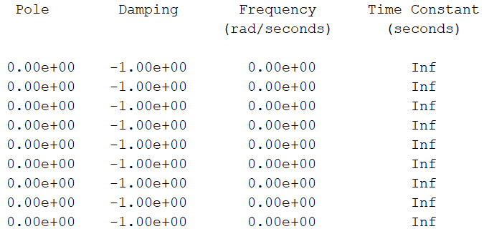
Fig 28: Poles of the open-loop system

Figure 28 provides us the poles of the transfer function for a first stability analysis. With the opened-loop system, we have zero pole only. This can be explained by the fact that the transfer functions have the following form: $\frac{1}{s^{2}}$. Therefore, the system is not stable without a closed-loop.

V-3-1 Precision Analysis
Now, let examine the precision performance with the opened-loop. Indeed, with the class of the transfer function, we can determine the position error, the speed error and the acceleration error. Therefore, let examine the transfer functions, determined with the function $tf()$ of Matlab Control System Toolbox:
$$\frac{q_{s1}}{q_{r1}}=\frac{0.02}{s^{2}}$$
$$\frac{q_{s2}}{q_{r2}}=\frac{0.02}{s^{2}}$$
$$\frac{q_{s3}}{q_{r3}}=\frac{0.02}{s^{2}}$$
Every transfer functions are class 2 functions. Thus, the position error and the speed error will be zero. The command is a position command and so, the system should be perfectly precise.

V-4 Closed-loop Analysis
Now, let calculate the closed feedback LTI system as define in Part V-2.
$$A_{cl}=\left[\begin{matrix}-0.4 & 0 & 0 & -0.04 & 0 & 0 & 0 & 0 & 0 \\ 0 & -0.4 & 0 & 0 & -0.04 & 0 & 0 & 0 & 0 \\ 0 & 0 & -0.4 & 0 & 0 & -0.04 & 0 & 0 & 0 \\ 0.5 & 0 & 0 & 0 & 0 & 0 & 0 & 0 & 0 \\ 0 & 0.5 & 0 & 0 & 0 & 0 & 0 & 0 & 0 \\ 0 & 0 & 0.5 & 0 & 0 & 0 & 0 & 0 & 0 \\ 0.0572 & 0 & 0 & 0.0057 & 0 & 0 & 0 & 0 & 0 \\ 0 & 0.0572 & 0 & 0 & 0.0057 & 0 & 0 & 0 & 0 \\ 0 & 0 & 0.0516 & 0 & 0 & 0.0052 & 0 & 0 & 0\end{matrix}\right]$$
$$B_{cl}=\left[\begin{matrix}0.4 & 0 & 0 & 0.04 & 0 & 0 \\ 0 & 0.4 & 0 & 0 & 0.04 & 0 \\ 0 & 0 & 0.4 & 0 & 0 & 0.04 \\ 0 & 0 & 0 & 0 & 0 & 0 \\ 0 & 0 & 0 & 0 & 0 & 0 \\ 0 & 0 & 0 & 0 & 0 & 0 \\ -0.0572 & 0 & 0 & -0.0057 & 0 & 0 \\ 0 & -0.0572 & 0 & 0 & -0.0057 & 0 \\ 0 & 0 & -0.0516 & 0 & 0 & -0.0052\end{matrix}\right]$$
$$C_{cl}=\left[\begin{matrix}1 & 0 & 0 & 0 & 0 & 0 & 0 & 0 & 0 \\ 0 & 1 & 0 & 0 & 0 & 0 & 0 & 0 & 0 \\ 0 & 0 & 1 & 0 & 0 & 0 & 0 & 0 & 0 \\ 0 & 0 & 0 & 1 & 0 & 0 & 0 & 0 & 0 \\ 0 & 0 & 0 & 0 & 1 & 0 & 0 & 0 & 0 \\ 0 & 0 & 0 & 0 & 0 & 1 & 0 & 0 & 0\end{matrix}\right]$$
$$D_{cl}=0_{6,6}$$

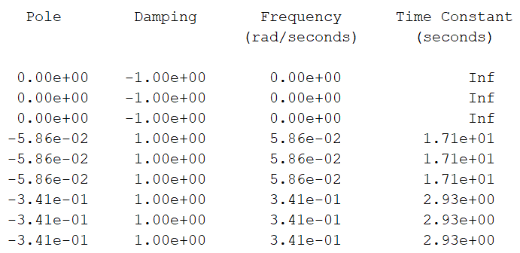
Fig 35: Poles of the closed-loop system

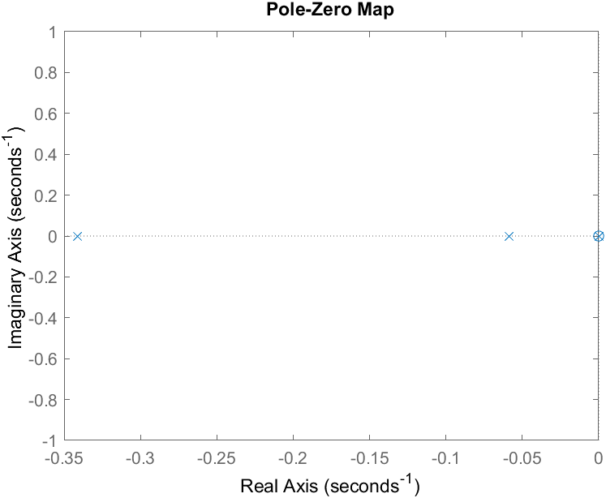
Fig 36: Pole map of the closed-loop system

In the closed-loop system, we have four negative real part poles, according to the Figures 35 and 36. All poles have a negative real part. Therefore, the system should be stable. Moreover, we can approximate this system by the dominant mode with the higher real part (closest from the imaginary axis): $-5.86×{10}^{-2}$. So, it will be a no-periodic response because of the damping of 1. With the abacus in Annex 6, we will not have an overtake and we will have a 5% time response of 85s ($ω_{n}=0.0586 rad/s$).
Let know examine the precision and the speed on the position command.

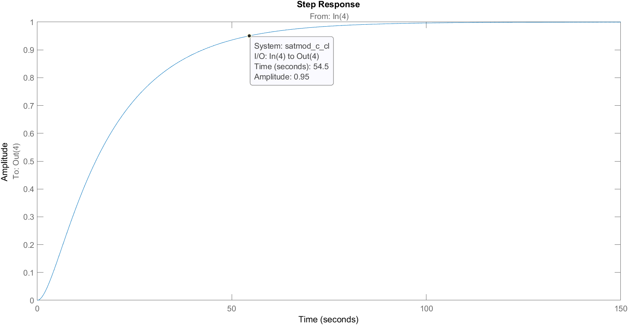
Fig 37: $q_{s1}(q_{r1})$ for a step value of 1

Fig 38: $q_{s2}(q_{r2})$ for a step value of 1

Fig 39: $q_{s3}(q_{r3})$ for a step value of 1

The position is commanded by the three first quaternion. It is the same response for the three quaternions. We can read a 5% time response of 54.5s. Therefore, we have a little difference with the approximate model. For each quaternion, the precision is perfect but the time response is relatively long.
To conclude, the system is stable and the precision is perfect.

V-5 Disturbance Analysis
We have seen previously the stability, the precision and the speed of the command. One of the most important thing in attitude control is the error due to a perturbation. So, let determine the LTI state equation of the perturbation:
$$A_{cld}=\left[\begin{matrix}-0.4 & 0 & 0 & -0.04 & 0 & 0 & 0 & 0 & 0 \\ 0 & -0.4 & 0 & 0 & -0.04 & 0 & 0 & 0 & 0 \\ 0 & 0 & -0.4 & 0 & 0 & -0.04 & 0 & 0 & 0 \\ 0.5 & 0 & 0 & 0 & 0 & 0 & 0 & 0 & 0 \\ 0 & 0.5 & 0 & 0 & 0 & 0 & 0 & 0 & 0 \\ 0 & 0 & 0.5 & 0 & 0 & 0 & 0 & 0 & 0 \\ 0 & 0 & 0 & 0 & 0 & 0 & 0 & 0 & 0 \\ 0 & 0 & 0 & 0 & 0 & 0 & 0 & 0 & 0 \\ 0 & 0 & 0 & 0 & 0 & 0 & 0 & 0 & 0\end{matrix}\right]$$
$$B_{cld}=\left[\begin{matrix}0.4 & 0 & 0 & 0.04 & 0 & 0 \\ 0 & 0.4 & 0 & 0 & 0.04 & 0 \\ 0 & 0 & 0.4 & 0 & 0 & 0.04 \\ 0 & 0 & 0 & 0 & 0 & 0 \\ 0 & 0 & 0 & 0 & 0 & 0 \\ 0 & 0 & 0 & 0 & 0 & 0 \\ 0 & 0 & 0 & 0 & 0 & 0 \\ 0 & 0 & 0 & 0 & 0 & 0 \\ 0 & 0 & 0 & 0 & 0 & 0\end{matrix}\right]$$
$$C_{cld}=\left[\begin{matrix}1 & 0 & 0 & 0 & 0 & 0 & 0 & 0 & 0 \\ 0 & 1 & 0 & 0 & 0 & 0 & 0 & 0 & 0 \\ 0 & 0 & 1 & 0 & 0 & 0 & 0 & 0 & 0 \\ 0 & 0 & 0 & 1 & 0 & 0 & 0 & 0 & 0 \\ 0 & 0 & 0 & 0 & 1 & 0 & 0 & 0 & 0 \\ 0 & 0 & 0 & 0 & 0 & 1 & 0 & 0 & 0\end{matrix}\right]$$
$$D_{cl}=0_{6,6}$$
Fig 40: Poles of the closed-loop disturbance system

Fig 41: Pole map of the closed-loop disturbance system

As we can see in the Figures 40 and 41, the behavior will be the same as the closed-loop system. Therefore, the system will be stable and the precision will be perfect even with a disturbance torque step. Moreover, there is an integration in the motor command (from the torque to the angular speed or the angular momentum) before the perturbation. So, the disturbance entry will be cancelled by this integration.

VI Experiment
Previously, the control and command law has been defined and the equation model in Part IV. Now, we have everything to build the table, simulate and experiment the table.

VI-1 Digital Model

VI-1-1 Equation Model
Let implement the law into the Matlab equation model in order to compare with the experimental measurement on the table. The equation model in Part IV will be taken (Fig 11) and the closed-loop and control law will be implemented with the same defined values.

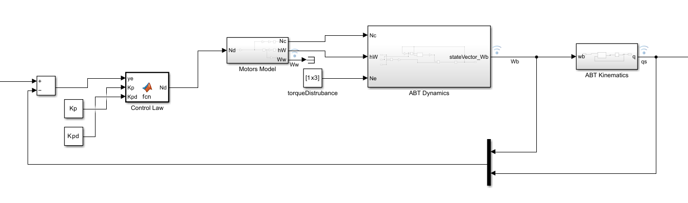
Fig 42: Closed-loop equation model

The control law (provided in Part V) is ensured by a Matlab function for matrix calculation as shown in the Figure 40 and the “mux” block allows us to have the good measurement state $y_{s}={[ω_{x}, ω_{y},ω_{z}, q_{1},q_{3},q_{3}]}^{T}$. Moreover, a disturbance torque is added to study the disturbance step response.

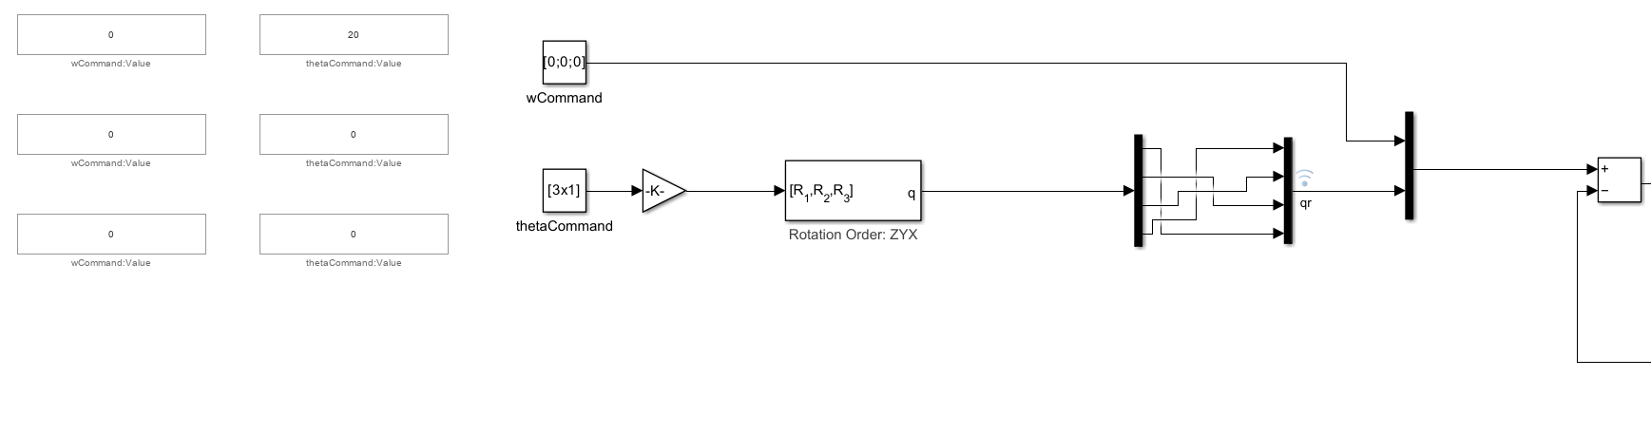
Fig 43: Command of the Matlab model simulation

As shown in the Figures 43, we still have $y_{r}={[ω_{x}, ω_{y},ω_{z}, q_{1},q_{3},q_{3}]}^{T}$. However, we need to provide a Euler’s angle command to have a concrete command. Indeed, the quaternions do not represent any concrete angles. Therefore, a conversion block from Euler’s Angles to quaternions. Then, we need to reorganize the quaternions because this block provides a quaternion vector as $y={[q_{4}, q_{1},q_{3},q_{3}]}^{T}$. So, we need to reorganize the vector to match the $y_{s}$ vector. We need an angular rate reference for the control law but the angular rate is not control (always set to zero).

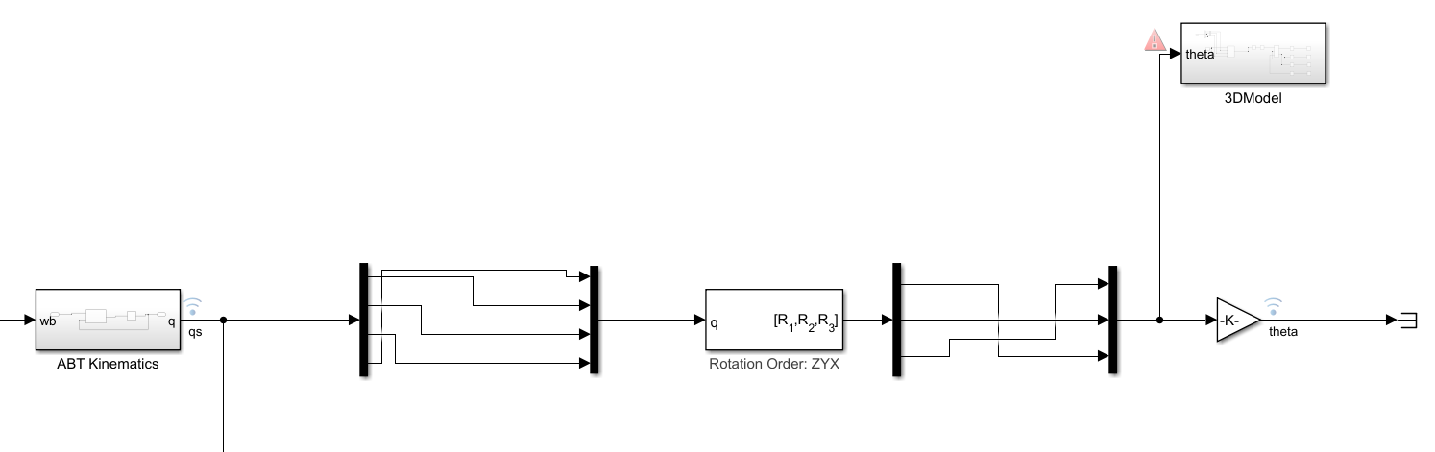
Fig 44: Processing of the ${[q_{1},q_{3},q_{3, }q_{4}]}^{T}$ vector and conversion

Now, let examine the processing of the measurement state equation in the Figure 44. Indeed, a conversion is made from quaternions to Euler’s angles and we have to reorganize the quaternions vectors at the in and out of the block. Then, we obtain the Euler’s angle vector and an 3D Animation in time thank to a Simscape model.

VI-1-2 Physic Model
Then, we are going to do exactly the same closed-loop and control law but with the physic model.

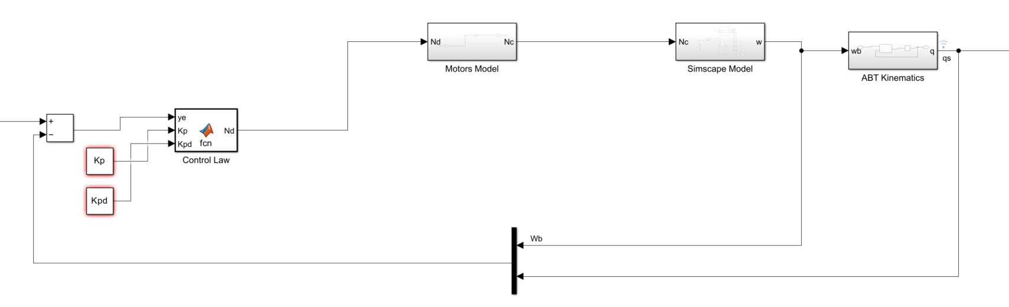
Fig 45: Closed-loop physic model

The command and the processing part are the same as the equation model.

VI-2 The Air Bearing Table

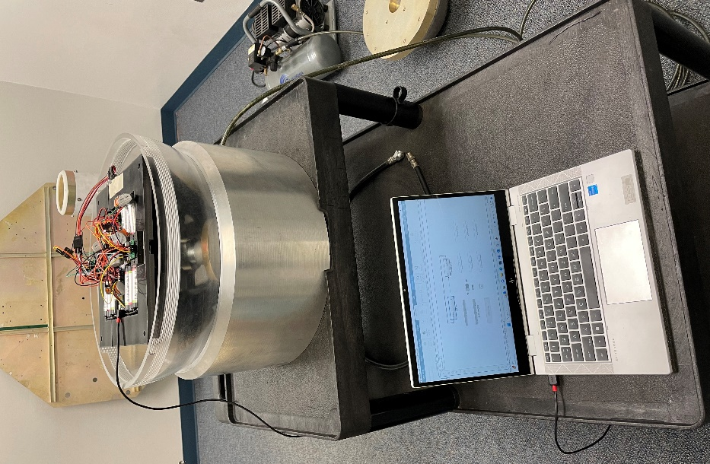
Fig 46: The Air Bearing Table

The Figure 46 shows the 3D impressed air bearing with the computer to initialize and launch the table. The compressor on the left provides pressurized air to reduce friction between the sphere and the platform as explains in Part III. Let’s have a closer look with the Figures 45 and 46:

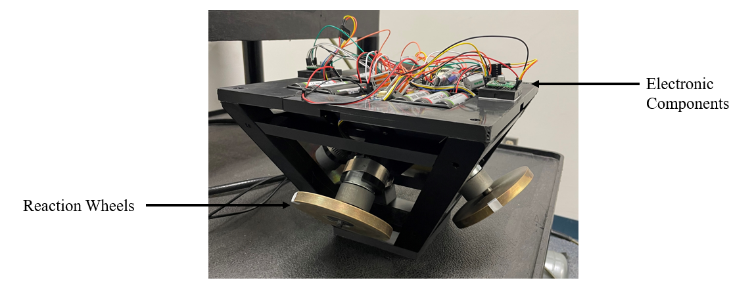
Fig 47: The carrier with the reaction wheels and the electronic components

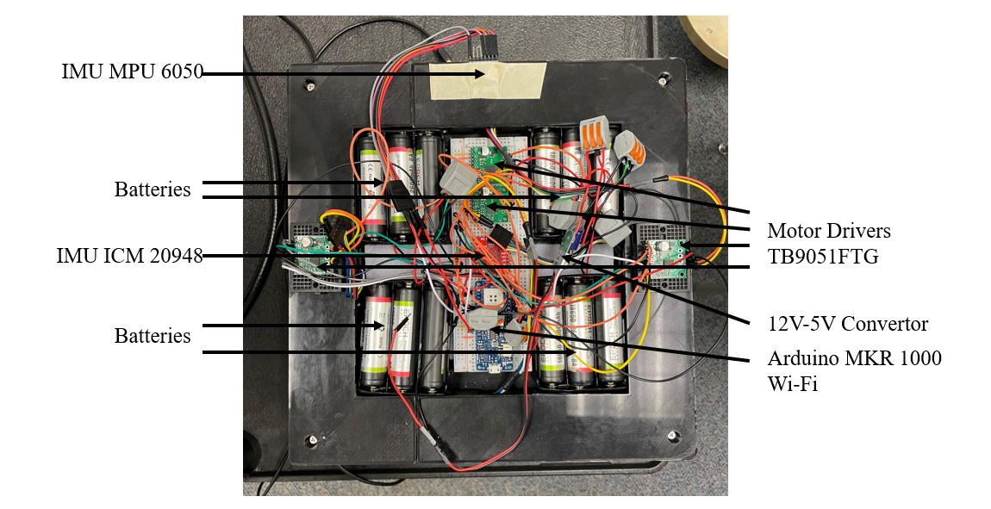
Fig 48: Electronic Components

As we can see, we followed the components description and architecture to guarantee a good balance. However, some modifications had to be made: two motor drivers do not fit in the electronic component area. So, they are outside the area, on the carrier and positioned in a symmetric way to keep the balance. Moreover, an another IMU add to be added. Indeed, the ICM 20948 IMU have some compatibility problem with the Simulink environment. The accelerometer and the magnetometer are working but not the gyroscope. Therefore, we had to add an MPU 6050 IMU to have gyroscopic information.

VI-3 The Simulink Command Program
Now, all the system and the architecture are defined. There is just one last thing to do: the Simulink program for the Arduino Board. Indeed, we have already use Simulink to determine the equation model and the command. Now, it will be used to create the program for the Arduino Board. The advantages of Simulink are that the use is very intuitive, the measures are easily monitored and some blocks are the same between the model and the command program.

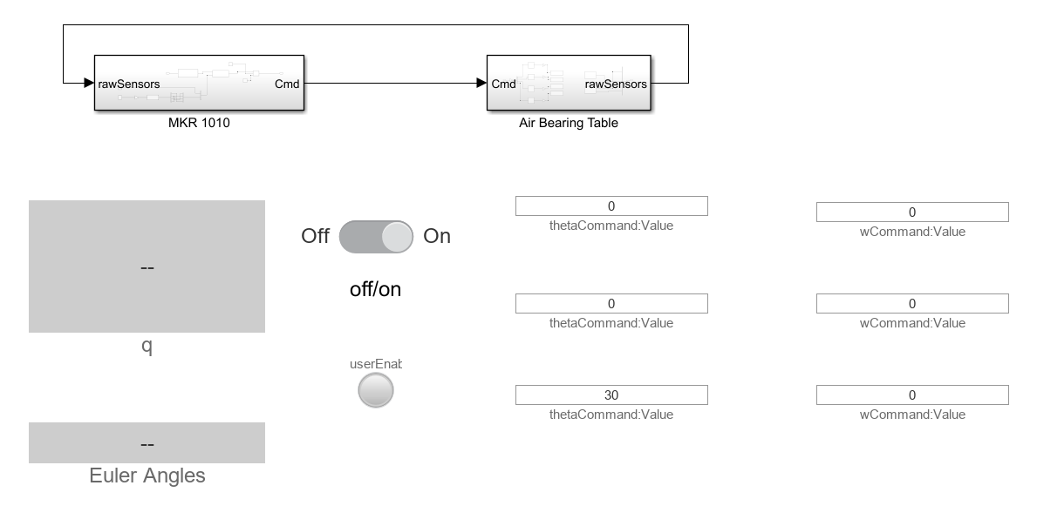
Fig 49: Simulink Command Program

The Figures 49 represents the first stage of the command program. On the left side, it is the reference vector (the command vector) in position and angular velocity. The last one is not a command but it is needed for the closed-loop control. On the right side, it is the monitored values of the quaternion and the conversion to the Euler Angles. At the center, there are an ON/OFF Button to stop the table and a green/red light to indicate the working state of the table. Now, let have a closer look to the MKR 1000 and AIR BEARING TABLE (ABT) blocks.

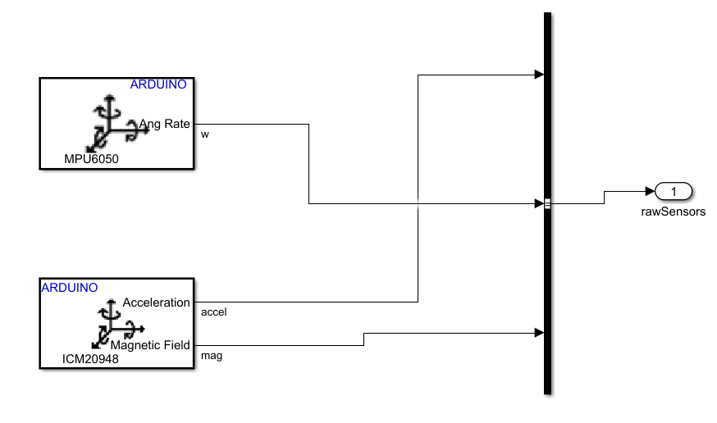
Fig 50: AIR BEARING TABLE block: Sensor part
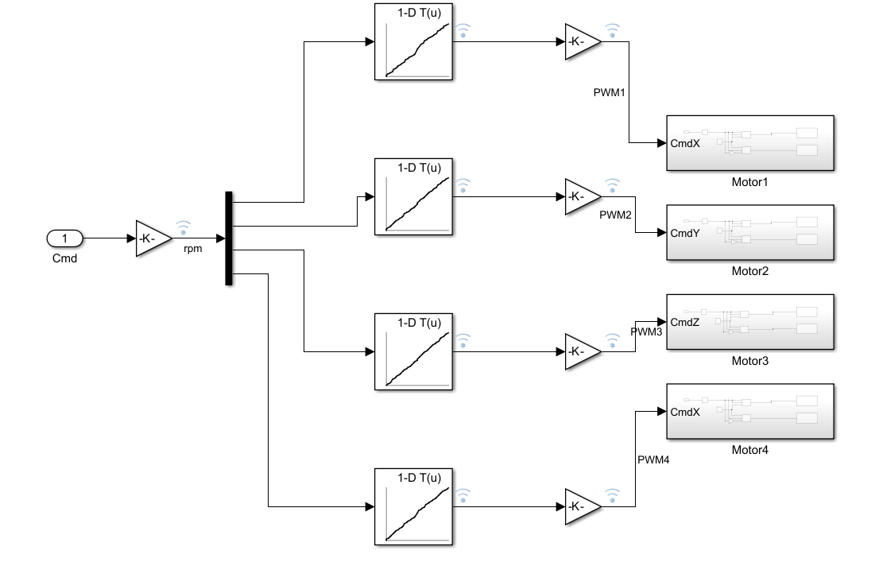
Fig 51: AIR BEARING TABLE block: Actuator part

The Figures 50 and 51 show the block content of the ABT block. The two sensor blocks are provided by Simulink Support Package for Arduino Hardware and a bus is created with all the sensor data. The other part is to send the command signal to the four motor. First, a conversion is made from rad/s to rotation per minute with some measurements for each motor (Annex 7). Then, the signal for each wheels follows another conversion from rpm to a PWM signal (between -1 and 1). A final conversion is made to have a PWM signal between -255 and 255.

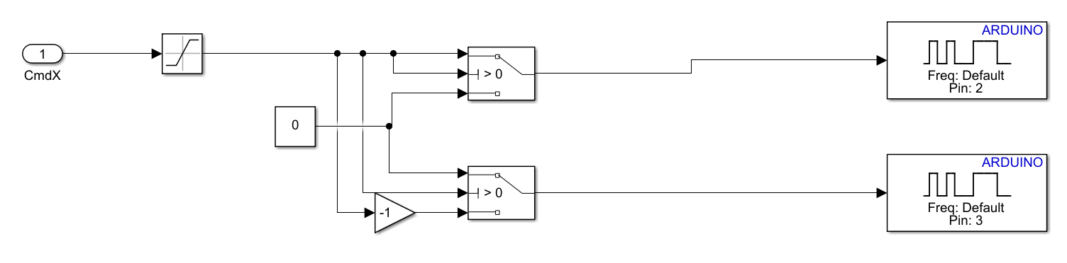
Fig 52: Block Command of a Motor

The Figures 52 shows the final stage of the motor command with the sending of the PWM signals to two pins where the motor driver is connected. One pin command a direction and the other pin command the other one. This is the command for one motor. Therefore, 8 pins will be needed to command the four reaction wheels.

Now, let have a look on the MKR 1000 block.

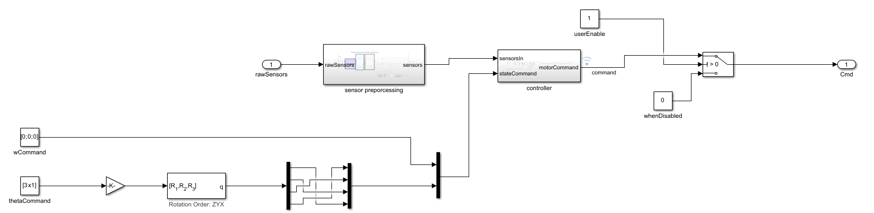
Fig 53: MKR 1000 block

This block is divided in three main parts: the sensor processing, the controller and the command. Let talk about the command. The control law is working with a quaternion reference vector. So, we need to provide a measurement vector in quaternion and a quaternion command vector. We are using the Euler Angles to set the reference because these are concrete angles. Therefore, we need a conversion from the Euler Angles to the quaternions in order to have the vector $y_{r}={[ω_{x}, ω_{y},ω_{z}, q_{1},q_{3},q_{3}]}^{T}$.

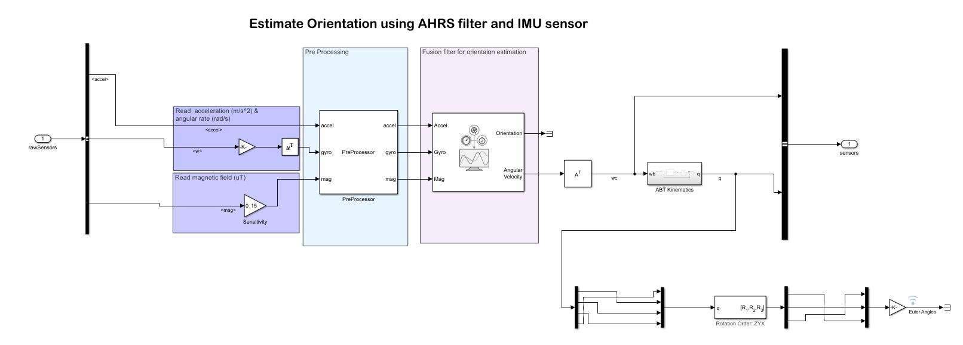
Fig 54: Sensor Processing Block

The sensor processing block is taking the sensor data and provide the position by a quaternion vector. Therefore, a processing is needed. The acceleration vector is directly used, a conversion from degree per second to rad/s is used and a sensitivity gain is settled for the magnetometer. Then, all this data is passing by a preprocessor block to align the axis of each sensors to the table axis. Finally, the data arrived in a AHRS (Attitude and Heading Reference System) filter provided by the Navigation toolbox add-on for Simulink. This filter provides an absolute position and angular velocity, free from deviation phenomena and this is how we managed to have the vector $y_{s}={[ω_{x}, ω_{y},ω_{z}, q_{1},q_{3},q_{3}]}^{T}$. A conversion is made to the Euler Angles for the monitoring of the table position.
However, the AHRS must be setup.

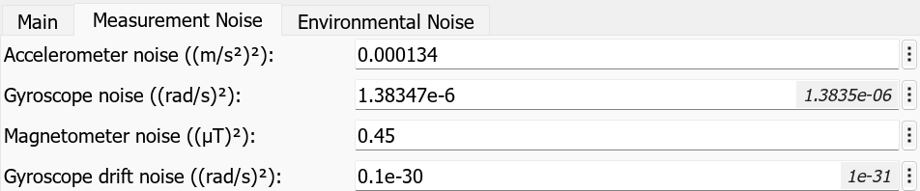
Fig 55: Measurement noise for the AHRS

The Figure 55 shows the block parameters of the AHRS block. In order to realize the configuration, the variances of each sensor signal have been made and put into the block.

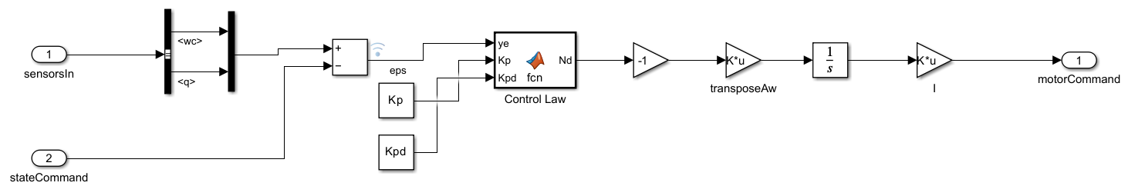
Fig 56: Controller Block

Once we have $y_{s}$ and $y_{r}$ vectors, we can implement the control law. It is exactly the same law as the digital model with the same parameters. This law is providing a torque command that we need to convert in angular velocities with the matrix $A_{W}$ and the inertia of each wheels.

VI-4 Digital Model Simulation
Everything is ready to launch the simulations with the equation model and the physic model. Moreover, every simulation has been made with a command of 30 degrees on the γ axis (Z).

VI-4-1 Equation Model

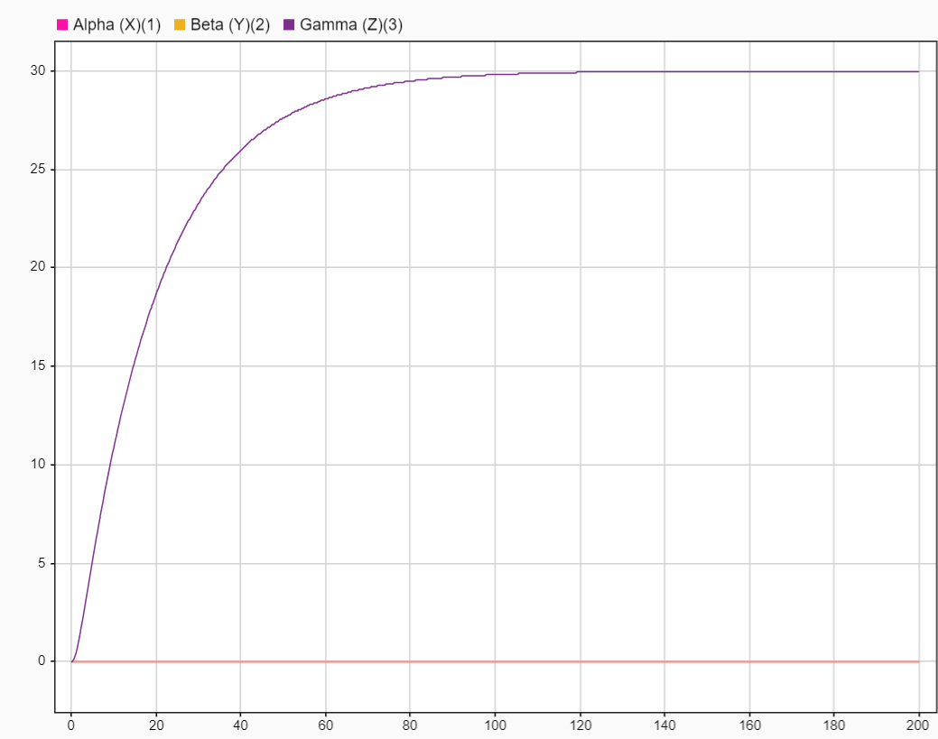
Fig 57: Euler Angles of the equation model for a 30° γ command

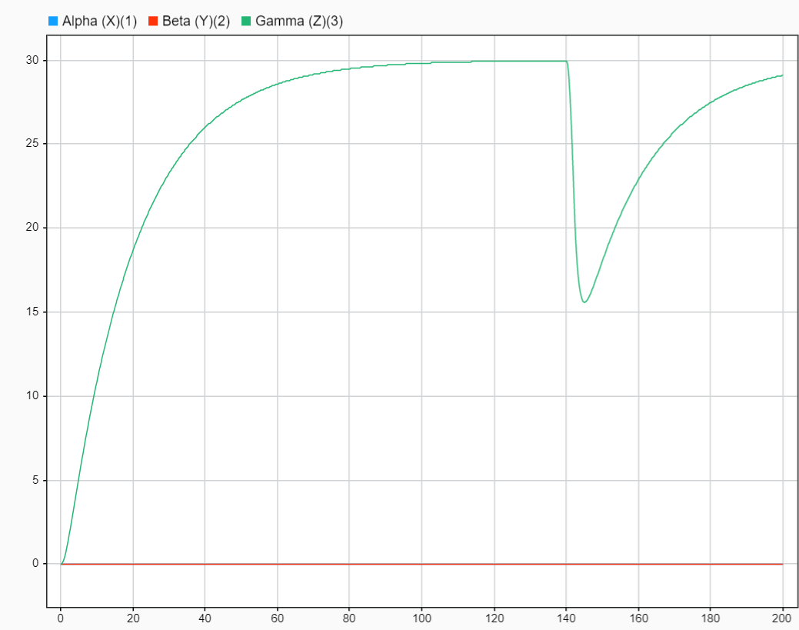
Fig 58: Euler Angles of the equation model for a 30° γ command with a disturbance on the γ axis at 140s

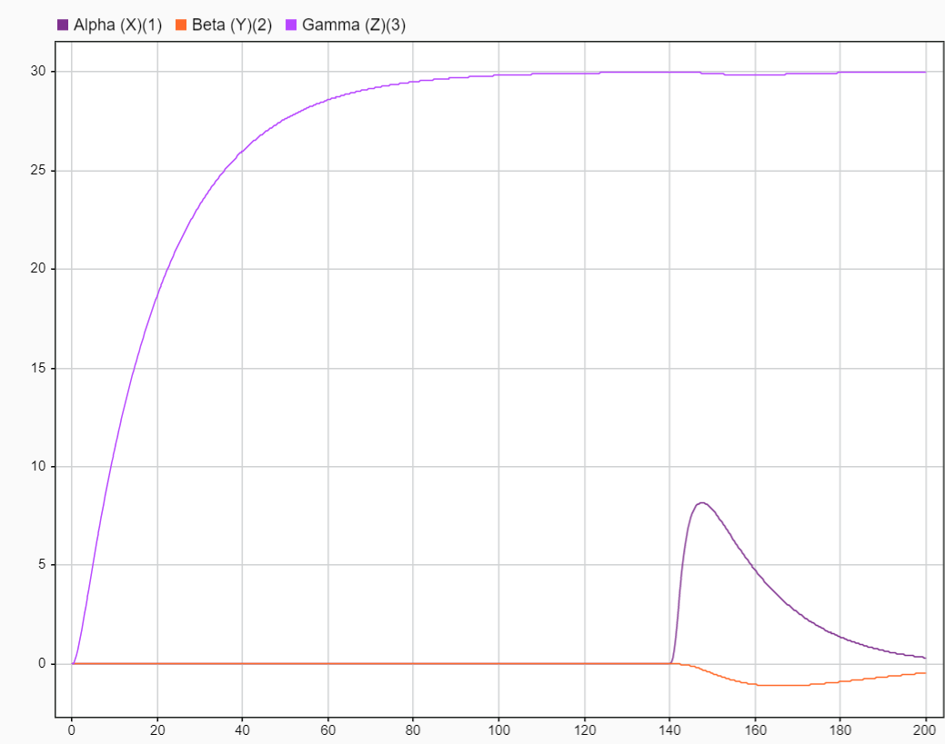
Fig 59: Euler Angles of the equation model for a 30° γ command with a disturbance on the α axis at 140s

From the Figure 57, we can say that the precision is good because the command is respected and the system is stable. The two other axis are not impacted by the command on the other one. Moreover, the simulation is really closed to the step simulation of the closed-loop state equation in Part V, especially with the time response.
Then, let examine the disturbance step response with the Figures 58 and 59. The response is stable, regardless of the axis of disturbance and the error is zero. Therefore, the system is not sensible to a step disturbance

VI-4-2 Physic Model
Now, let analyze the simulation of the physic model made on the Simscape environment.

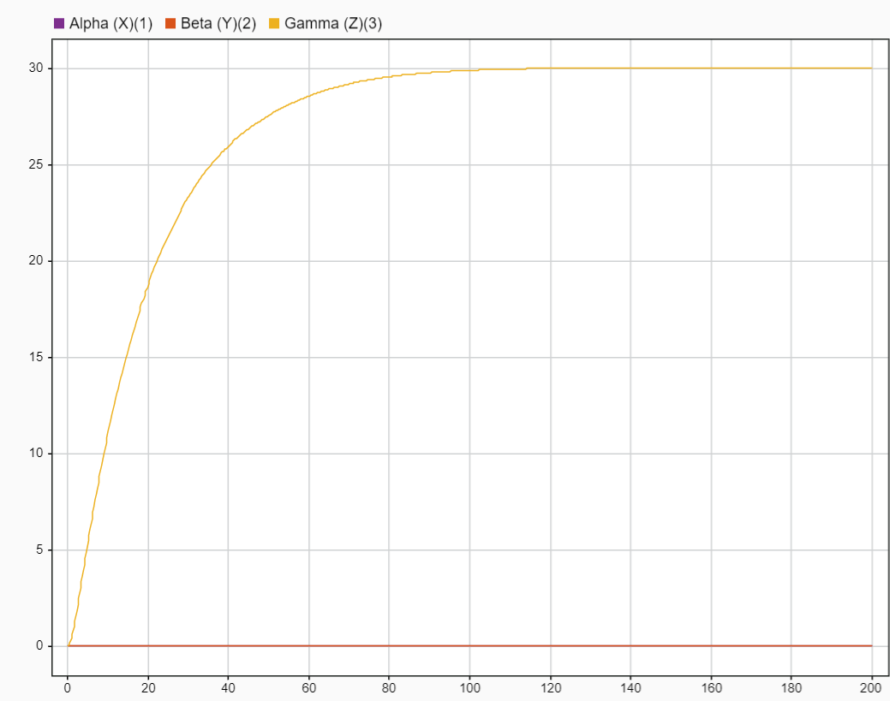
Fig 60: Euler Angles of the physic model for a 30° γ command

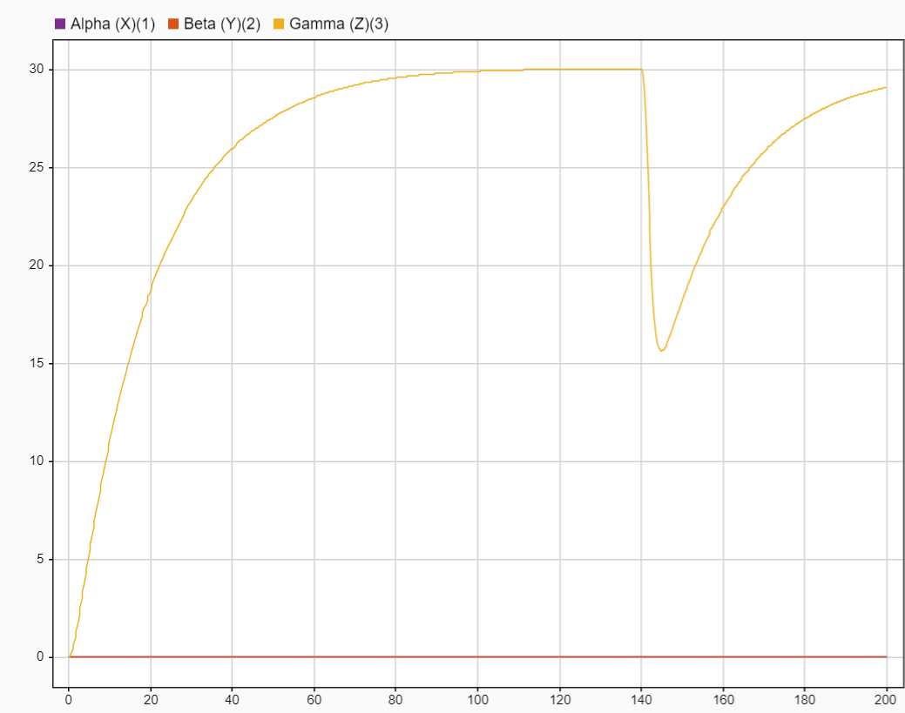
Fig 61: Euler Angles of the equation model for a 30° γ command with a disturbance on the γ axis at 140s

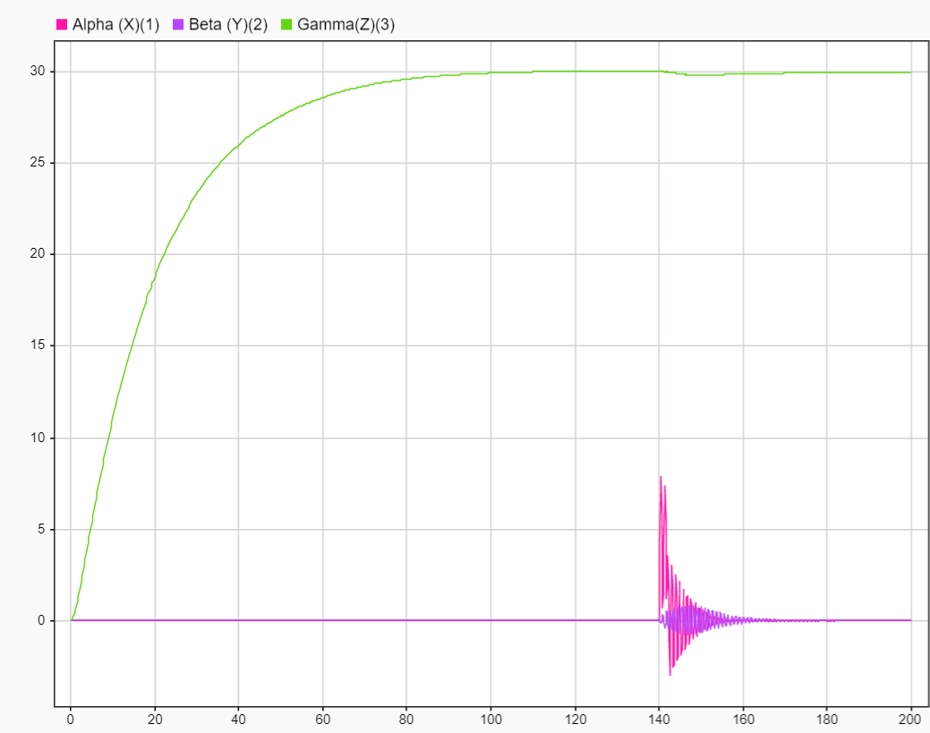
Fig 62: Euler Angles of the equation model for a 30° γ command with a disturbance on the α axis at 140s

Concerning the command and the disturbance analysis with the Figures 60, 61 and 62, the results are the same as the equation model. However, the disturbance on the α axis is very interesting. Indeed, we can see some oscillations on the α and β axis before reaching again the stable state without any error precision. Therefore, the system is still stable in front of a step disturbance but there is a pseudo-periodic transition state.

VI-5 Air Bearing Table Measures
Now, it is time to realize and assess the measures on the air bearing table. As explain in the previous parts, the closed-loop control is the same with the same parameters and the command is the same also (30° on the γ axis).

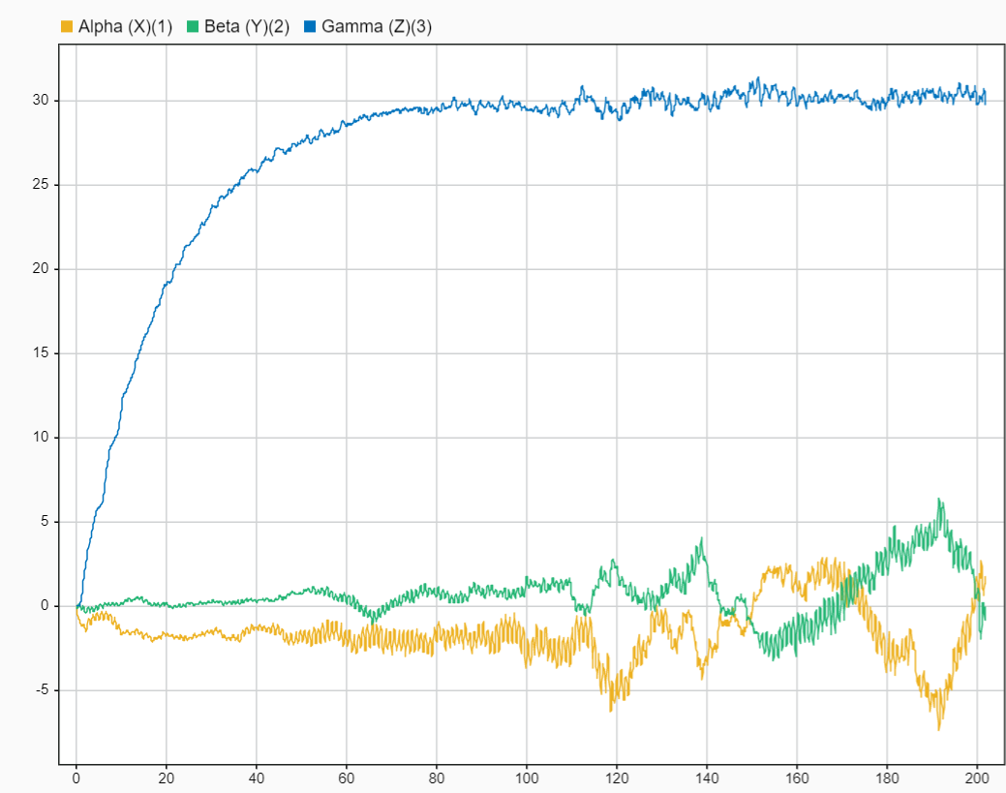
Fig 63: Euler Angles of the Air Bearing Table for a 30° γ command

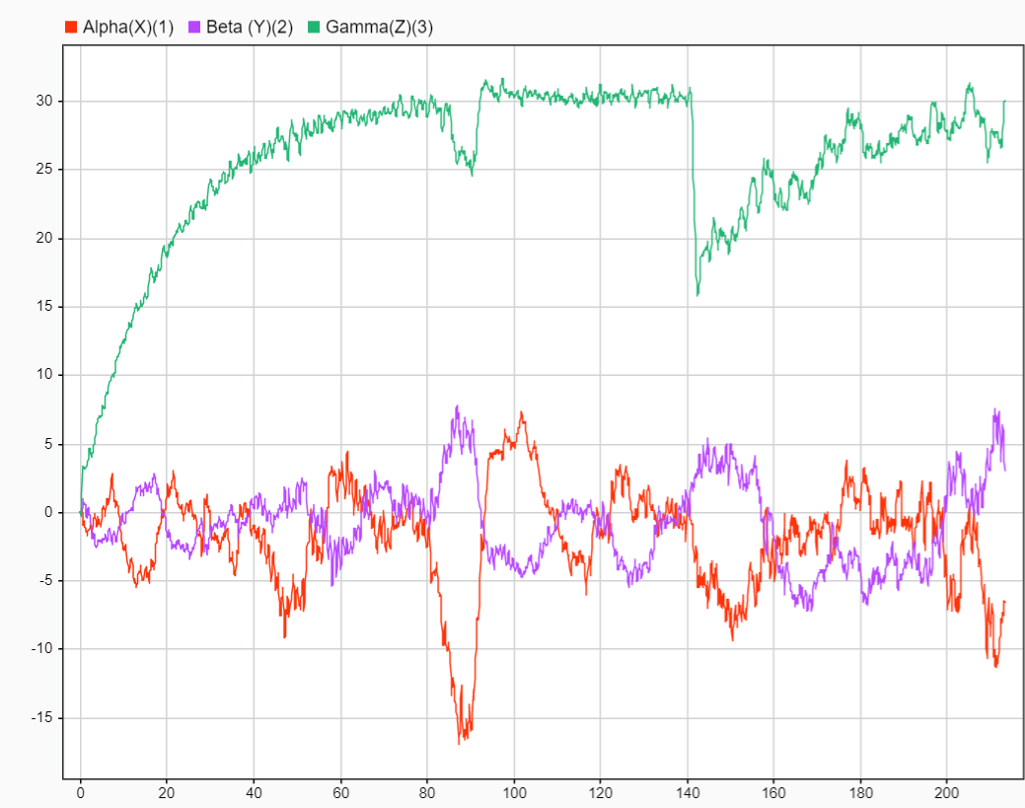
Fig 64: Euler Angles of the Air Bearing Table for a 30° γ command with a disturbance on the γ axis at 140s

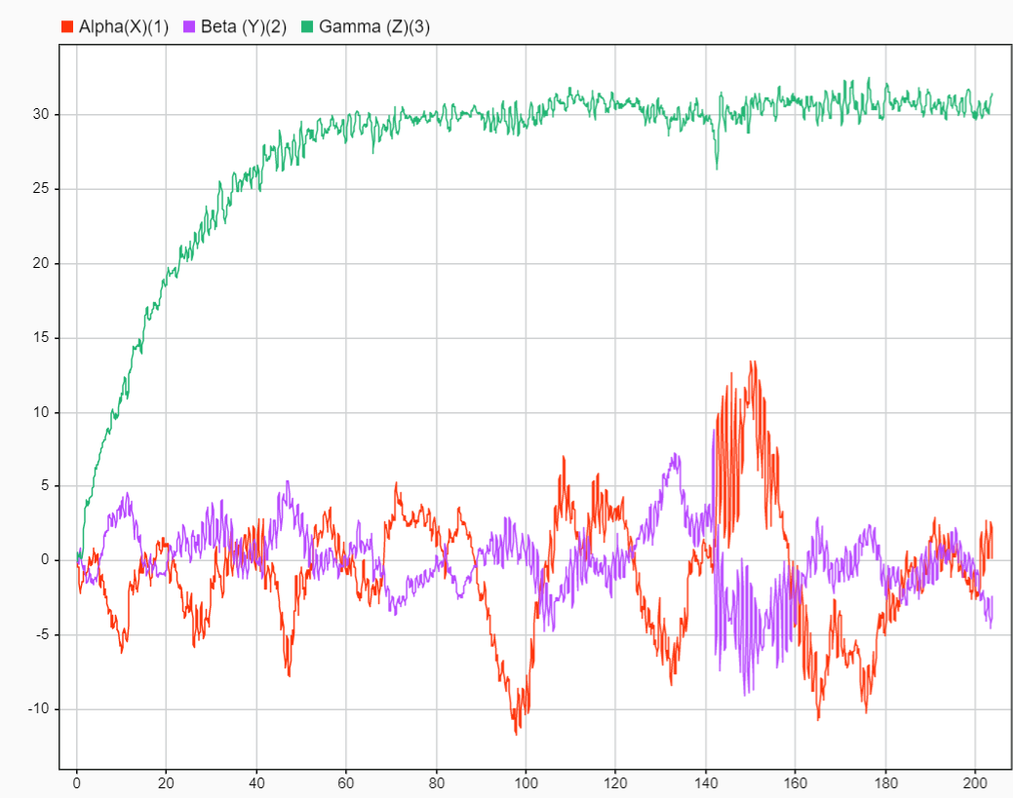
Fig 65: Euler Angles of the Air Bearing Table for a 30° γ command with a disturbance on the α axis at 140s

With the Figures 63, we can see that the table is stable for a step command and the precision is good (30° γ command). However, there are strong oscillations for the two other axis but the oscillations are near the command (which are 0 for these axis). The reasons for these oscillations are the fact that the table is not perfectly balanced. The center of gravity is not at the center of rotation. Nevertheless, with the theoretical symmetry, the center of gravity should be at the center of the table along the Z axis. But the symmetric is not perfect. So, the two first coordinates of the center of gravity are not zero. Therefore, there is a gravity disturbance. As explain before, this is why we cannot command the table on the two first axis. Another explanation could be the fact that there are some errors on the position sensors, despite the AHRS filter. The system is trying to correct a gap between the command and the measured position which is not the case in reality. The power of the Arduino board could be another reason of the oscillations. Indeed, if the processor is too slow, the control law cannot provide the good command or the sensors cannot provide the good position.
Concerning the disturbance analysis with the Figures 64 and 65, the conclusions are the same as the equation and physic models. The system is stable and the precision is good, even with perturbation. However, there are still some strong oscillations along 0 degree for the two first axis.

VI-6 Comparison
All the measures have been made and the analysis too. Now, we can assess if the simulations are relevant compared to the air bearing table measurements. As said before, the equation model and the physic model are really closed. So, they will not be compared. Only the physic model and the air bearing table measurements will be analyzed because the physic model seems to be more relevant than the equation model. Indeed, the geometry and the mass distribution are described in the physic model.

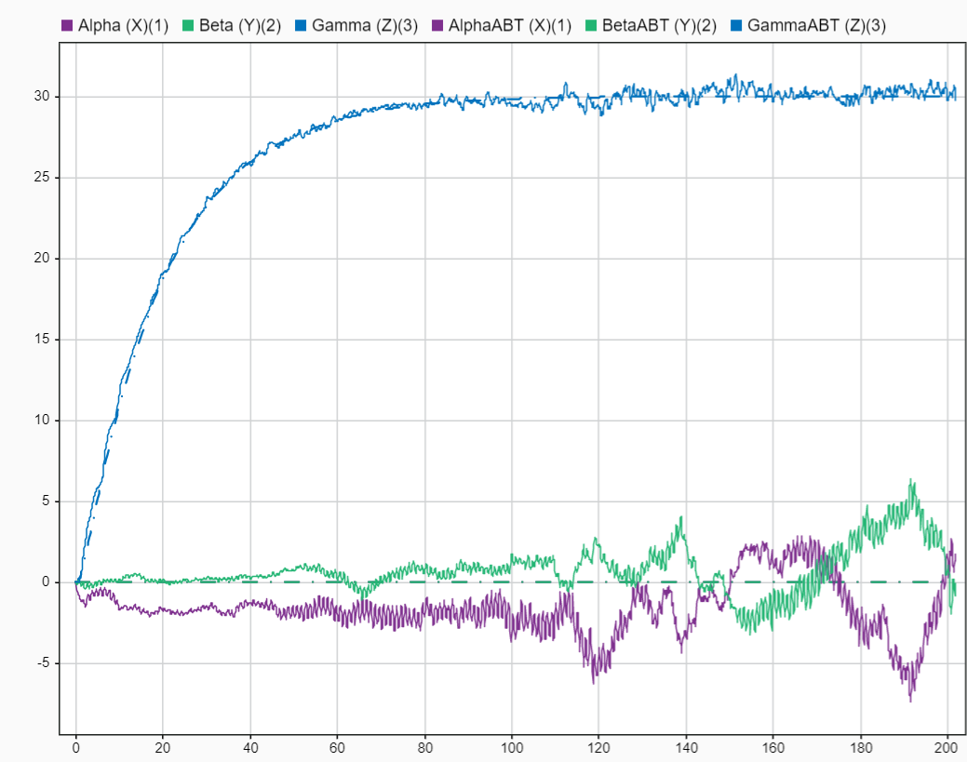
Fig 66: Euler Angles of the Air Bearing Table and the physic model for a 30° γ command

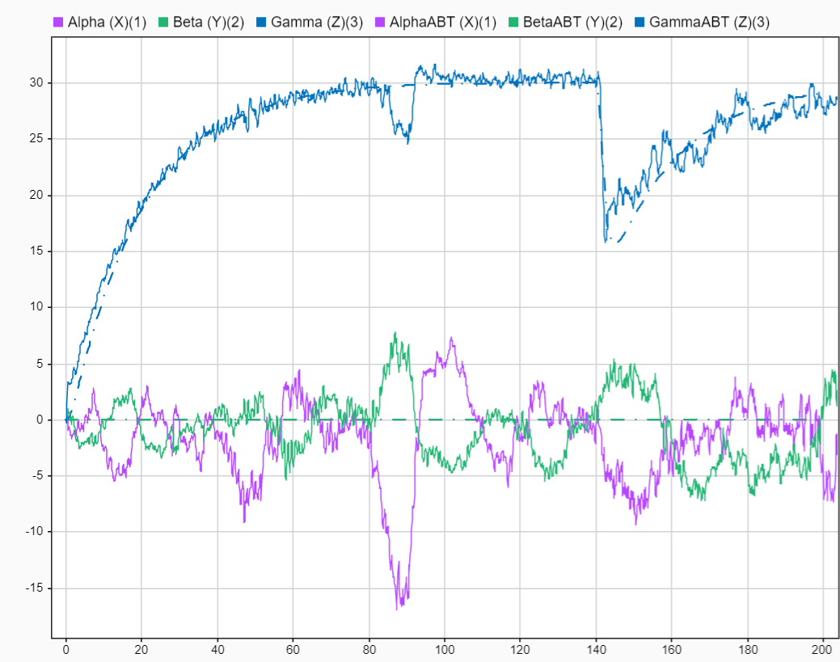
Fig 67: Euler Angles of the Air Bearing Table and the physic model for a 30° γ command with a disturbance on the γ axis at 140s

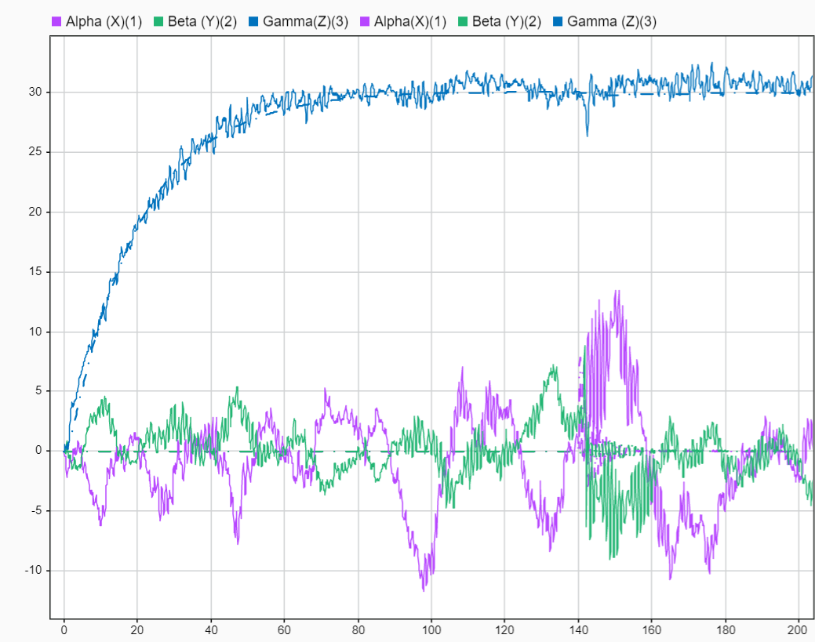
Fig 68: Euler Angles of the Air Bearing Table and the physic model for a 30° γ command with a disturbance on the α axis at 140s

We can say that, on the Figure 66, the γ axis of the air bearing table is very closed of the one on the physic model. However, the oscillations are not in the physic model. Indeed, this model has a perfect symmetry. Therefore, there is no oscillation and gravity disturbance without disturbance torque. Concerning the disturbance measurements in the Figure 67, both γ signals are really closed too. The Figure 68 shows that the conclusions on the γ axis are the same but there are some oscillations but not as much as the table measurements. Therefore, we can say that some oscillations could be expected with a α or β axis disturbance.
We can conclude that the physic (and the equation) model can be used to design the closed-loop control and set up the gain values in order to optimize the control law.

VII Conclusion
The main purpose of this project was to develop an experimental air bearing table with 3 degrees of freedom of the rotational motion to simulate the attitude dynamic behavior of the object in a frictionless environment such as space, for the Department of Astronautics (DFAS) in the United States Air Force Academy. In order to achieve this goal, the different stabilizations and actuators has been mentioned in order to choose the components and define the architecture of the future air bearing table. Once the table is designed with a CAD software, the attitude dynamics and kinematics equation has been determined in order to build some digital model on Matlab Simulink and design a control law for the closed-loop control.
Our results show us that first, the equation and physic model are relevant to simulate the table. Secondly, the simulation shows the control law is well suitable for the command. The precision, the speed and the stability are good and suitable with a satellite use. This control performances are validated by the experiment on the air bearing table which confirm also both digital models.
However, this project has some strong perspectives. Indeed, the control law is certainly not optimized in term of speed or reactivity in front of oscillations. Moreover, this air bearing table is uncomplete. First, the system is not perfectly balanced: the center of gravity is not at the center of rotation. Therefore, a counterweight part has to been designed. Second, the system does not deal with the saturation problem of the reaction wheels. Some gas valves or fans has to be added.
The air bearing table has been designed on a sphere platform with a frictionless environment provided by compressed air, as shown in Figure 10. The final purpose of the project is to build a bigger air bearing table (Figure 69) with different actuators (reaction wheels, gyroscopic actuators, fans or gas valves) and precise sensor position. The current state of this work provides everything to configure reaction wheels architecture and command, regardless the number and the position of these reaction wheels.

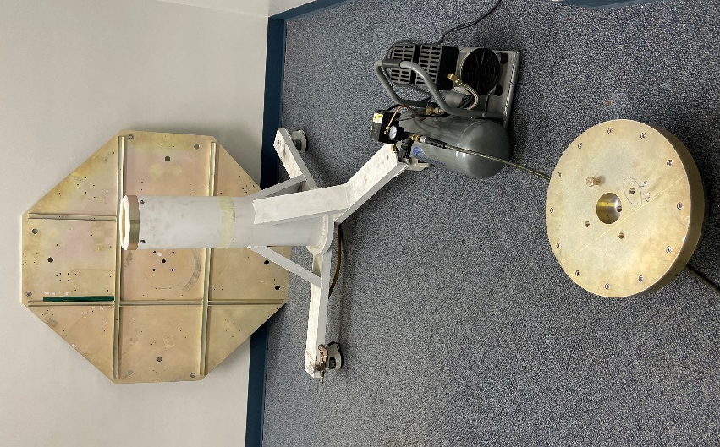
Fig 69: The future air bearing table

The equations of motions are the same between the table. So, the equation model is still suitable to this table. The next steps will be to design the fans or gas valves architecture to deal with the saturation problem. Therefore, all the digital model must be upgraded and the control law as well. Then, the implementation of other actuators such as gyroscopic actuators could be assessed. Moreover, the precision of the AHRS system must be improved. On top of the IMU sensors, an orientation determination by cameras can be develop such as the satellites that have an absolute star orientation. A final step could be the implementation of an automatic or manual mass balancing system to ensure the balance of the table.
Finally, once all of this will be done, everything will be ready to create a new lab for the USAFA cadets in order to work on attitude determination and control system.

References
[1] Salas, E. B., (2023) Number of active satellites by year 1957-2022, statista.com/statistics/897719/number-of-active-satellites-by-year/

[2] Samuels, M.A (2014) The design and testing of a three-degree-of-freedom small satellite simulator using a linear controller with feedback linearization and trajectory generation, Mechanical Engineering, Utah State University.

[3] Oliviera, A. M., Kuga, H. K., Carrara, V., (2015) Air bearing platforms for simulation of spacecraft attitude control systems, Instituto Nacional de Pesquisas Espaciais.

[4] Kwan, T. H., Lee, K. M., Yan, J., Wu, X., (2006) An air bearing table for satellite attitude control simulation, University of Sydney.

[5] Ismail, Z., Varatharajoo, R., (2009) A study of reaction wheel configuration for a 3-axis satellite attitude control, Science Direct.

[6] Blanke, M., Larsen, B., (2010) Satellite dynamics and control in a quaternion formulation, Lecture note for course 31365, Technical University of Denmark

[7] Hughes, P. C., (2004) Spacecraft attitude dynamics, Dover Publications.

[8] Kim, P., (2013) Rigid body dynamics for beginners: Euler angles & Quaternions, CreateSpace Independent Publishing Platform.

[9] Bateman.F, Livre de cours d’automatique, Ecole de l’Air et de l’Espace.

Annex

Annex 1: Air bearing table component specifications
Every component is considered as homogenous and $I$ are the inertia matrices at the center of rotation. All the values have been calculated with Autodesk Fusion 360. Electronic components are negligible in front of the sphere, the carrier, the batteries and the reaction wheel assemblies.

Sphere
$$Mass=2.652 kg$$
$$Bounding Box=0.4×0.4×0.2 m$$
$$I≈\left[\begin{matrix}0.072 & 0 & 0 \\ 0 & 0.072 & 0 \\ 0 & 0 & 0.07\end{matrix}\right]kg.m^{2}$$

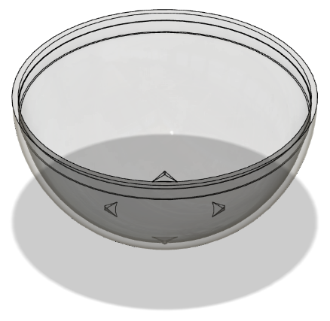
Fig 70: CAD Model of the sphere

Carrier
$$Mass=1.2 kg$$
$$Bounding Box=0.272×0.272×0.180 m$$
$$I≈\left[\begin{matrix}0.025 & 0 & 0 \\ 0 & 0.025 & 0 \\ 0 & 0 & 0.011\end{matrix}\right]kg.m^{2}$$

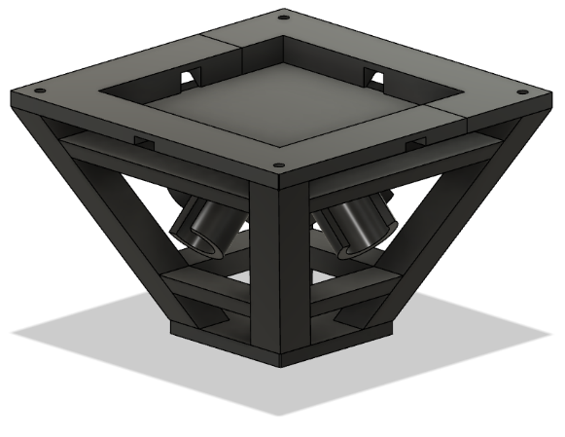
Fig 71: CAD Model of the carrier

Motor and wheel $(\vec{y}, -\vec{z})$
Motor:
$$Mass= 0.175 kg$$
$$Bounding Box=0.086×0.037×0.076 m$$
$$I≈\left[\begin{matrix}0.003 & 0 & 0 \\ 0 & 0.001 & 0.001 \\ 0 & 0.001 & 0.001\end{matrix}\right]kg.m^{2}$$

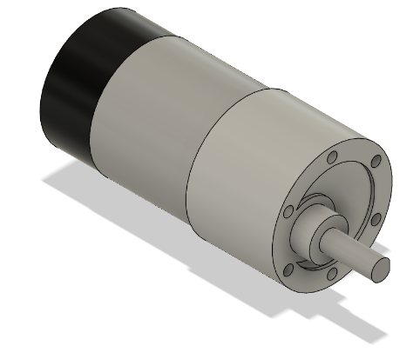
Fig 72: CAD model of the motor

Wheel:
$$Mass= 0.651 kg$$
$$Bounding Box=0.100×0.078×0.078 m$$
$$I≈\left[\begin{matrix}0.017 & 0 & 0 \\ 0 & 0.008 & 0.008 \\ 0 & 0.008 & 0.01\end{matrix}\right]kg.m^{2}$$

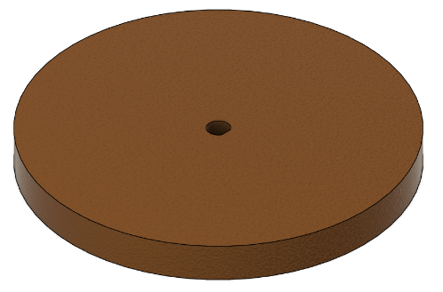
Fig 73: CAD Model of the wheel

Motor and wheel $(-\vec{x}, -\vec{z})$
Motor:
$$Mass= 0.175 kg$$
$$Bounding Box=0.086×0.037×0.076 m$$
$$I≈\left[\begin{matrix}0.001 & 0 & -0.001 \\ 0 & 0.003 & 0 \\ -0.001 & 0 & 0.001\end{matrix}\right]kg.m^{2}$$

Wheel:
$$Mass= 0.175 kg$$
$$Bounding Box=0.086×0.037×0.076 m$$
$$I≈\left[\begin{matrix}0.008 & 0 & -0.008 \\ 0 & 0.0017 & 0 \\ -0.008 & 0.001 & 0.01\end{matrix}\right] kg.m^{2}$$

Motor and wheel $(-\vec{y}, -\vec{z})$
Motor:
$$Mass= 0.175 kg$$
$$Bounding Box=0.086×0.037×0.076 m$$
$$I≈\left[\begin{matrix}0.003 & 0 & 0 \\ 0 & 0.001 & -0.001 \\ 0.00 & -0.001 & 0.001\end{matrix}\right]kg.m^{2}$$

Wheel:
$$Mass= 0.175 kg$$
$$Bounding Box=0.086×0.037×0.076 m$$
$$I≈\left[\begin{matrix}0.017 & 0 & 0 \\ 0 & 0.008 & -0.008 \\ 0 & -0.008 & 0.01\end{matrix}\right]kg.m^{2}$$

Motor and wheel $(\vec{x}, -\vec{z})$
Motor:
$$Mass= 0.175 kg$$
$$Bounding Box=0.086×0.037×0.076 m$$
$$I≈\left[\begin{matrix}0.001 & 0 & 0.001 \\ 0 & 0.003 & 0 \\ 0.001 & 0 & 0.001\end{matrix}\right]kg.m^{2}$$

Wheel:
$$Mass= 0.175 kg$$
$$Bounding Box=0.086×0.037×0.076 m$$
$$I≈\left[\begin{matrix}0.008 & 0 & 0.008 \\ 0 & 0.017 & 0 \\ 0.008 & 0 & 0.01\end{matrix}\right]kg.m^{2}$$

Battery $(-\vec{x}, \vec{y})$
$$Mass= 0.158 kg$$
$$Bounding Box=0.060×0.075×0.020 m$$
$$I≈\left[\begin{matrix}0.001 & 0.001 & 0 \\ 0.001 & 0.001 & 0 \\ 0 & 0 & 0.001\end{matrix}\right]kg.m^{2}$$

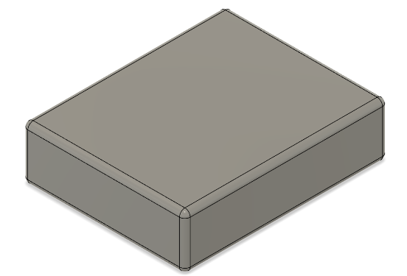
Fig 74: CAD Model of the battery

Battery $(-\vec{x},- \vec{y})$
$$Mass= 0.158 kg$$
$$Bounding Box=0.060×0.075×0.020 m$$
$$I≈\left[\begin{matrix}0.001 & -0.001 & 0 \\ -0.001 & 0.001 & 0 \\ 0 & 0 & 0.001\end{matrix}\right] kg.m^{2}$$

Battery $(\vec{x},-\vec{y})$
$$Mass= 0.158 kg$$
$$Bounding Box=0.060×0.075×0.020 m$$
$$I≈\left[\begin{matrix}0.001 & 0.001 & 0 \\ 0.001 & 0.001 & 0 \\ 0 & 0 & 0.001\end{matrix}\right]kg.m^{2}$$

Battery $(\vec{x}, \vec{y})$
$$Mass= 0.158 kg$$
$$Bounding Box=0.060×0.075×0.020 m$$
$$I≈\left[\begin{matrix}0.001 & -0.001 & 0 \\ -0.001 & 0.001 & 0 \\ 0 & 0 & 0.001\end{matrix}\right]kg.m^{2}$$

Annex 2: Matlab Workspace

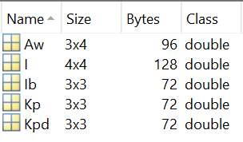
Fig 75: Matlab Workspace

Annex 3: Linearization of nonlinear MIMO (Multi Input Multi Output) model and state model
Let consider a system described by the nonlinear matrix (or vector) equation:
$$\dot{x}(t)=f(x\left(t\right),u\left(t\right))$$
$$y(t)=g(x\left(t\right),u\left(t\right))$$
Where $x∈R^{n}$ is the state vector, $u∈R^{m}$ the input state, $y∈R^{k}$ the measurement vector. We would like to obtain a model that describes operation around a point of operation defined by $\dot{\overline{x}}, \overline{x},\overline{u}$. Therefore, the small deviation from the trajectory is:
$$x=\overline{x}+\tilde{x}$$
$$u=\overline{u}+\tilde{u}$$
$$y=\overline{y}+\tilde{y}$$
Taylor expansion gives:
$$\dot{\tilde{x}}+\dot{\overline{x}}=f\left(\overline{x},\overline{u}\right)+\frac{∂f(\overline{x},\overline{u})}{∂x}\tilde{x}+\frac{∂f\left(\overline{x},\overline{u}\right)}{∂u}\tilde{u}+…$$
$$\dot{\tilde{y}}+\dot{\overline{y}}=g\left(\overline{x},\overline{u}\right)+\frac{∂g(\overline{x},\overline{u})}{∂x}\tilde{x}+\frac{∂g\left(\overline{x},\overline{u}\right)}{∂u}\tilde{u}+…$$
Using that $\dot{\overline{x}}=g\left(\overline{x},\overline{u}\right), \overline{y}= g\left(\overline{x},\overline{u}\right)$ and considering the first order of the Taylor expansion:
$$\dot{\tilde{x}}=\frac{∂f\left(\overline{x},\overline{u}\right)}{∂x}\tilde{x}+\frac{∂f\left(\overline{x},\overline{u}\right)}{∂u}\tilde{u}$$
$$\dot{\tilde{y}}=\frac{∂g(\overline{x},\overline{u})}{∂x}\tilde{x}+\frac{∂g\left(\overline{x},\overline{u}\right)}{∂u}\tilde{u}$$
And so:
$$\dot{\tilde{x}}=A\tilde{x}+B\tilde{u}$$
$$\dot{\tilde{y}}=C\tilde{x}+D\tilde{u}$$
With:
$$A=\frac{∂f\left(\overline{x},\overline{u}\right)}{∂x} B=\frac{∂f\left(\overline{x},\overline{u}\right)}{∂u}$$
$$C=\frac{∂g(\overline{x},\overline{u})}{∂x} D=\frac{∂g\left(\overline{x},\overline{u}\right)}{∂u}$$
Where $A$ is the dynamic or state matrix, $B$ is the command matrix, $C$ is the measurement or output matrix and $D$ is the direct transmission matrix. Moreover, the matrices $A$ and $B$ are defined by the derivatives of the vector valued function $f$ with respect to vectors $x$ and $u$ (respectively $C$ and $D$ by $g$). The derivation of a vector with respect to another vector is referred to as the Jacobian:
$$\frac{∂f\left(\overline{x},\overline{u}\right)}{∂x}=\left(\begin{matrix}\frac{∂f_{1}}{∂x_{1}} & ⋯ & \frac{∂f_{1}}{∂x_{m}} \\ ⋮ & ⋱ & ⋮ \\ \frac{∂f_{n}}{∂x_{1}} & ⋯ & \frac{∂f_{n}}{∂x_{m}}\end{matrix}\right)$$

Annex 4: Laplace transform of a linear time-invariant (LTI) MIMO system
Let consider a system described by this state-space model:
$$\dot{x}(t)=Ax\left(t\right)+Bu(t)$$
$$y(t)=Cx\left(t\right)+Du(t)$$
Applying the Laplace transform to the previous model gives:
$$sx\left(s\right)=Ax\left(s\right)+Bu\left(s\right)+x(t_{0})$$
$$y\left(s\right)=Cx\left(s\right)+Du\left(s\right)$$
With $I∈R^{n×n}$, we can rewrite:
$$sIx\left(s\right)=Ax\left(s\right)+Bu\left(s\right)+x(t_{0})$$
$$⇔\left(sI-A\right)x\left(s\right)=Bu\left(s\right)+x(t_{0})$$
$$⇔x\left(s\right)={\left(sI-A\right)}^{-1}(Bu\left(s\right)+x\left(t_{0}\right))$$
And:
$$y\left(s\right)=\left(C{\left(sI-A\right)}^{-1}B+D\right)+C{\left(sI-A\right)}^{-1}Bx(t_{0})$$
The transfer function $H(s)$ from input $u(s)$ to output y(s) is:
$$y\left(s\right)=H\left(s\right)u\left(s\right)=\left(C{\left(sI-A\right)}^{-1}B+D\right)u(s)$$
Where $H(s)∈C^{k×m}$ and each element is a SISO (Single Input Single Output) transfer function from a particular input to a particular output. Moreover, all transfer function in $H(s)$ have the same denominator $det⁡(sI-A)$. This point will be important for the stability.
The stability of a transfer function is determined by the roots of its denominator (the poles of the system) and determine with:
$$\det\left(sI-A\right)=0$$
Which are also the eigenvalues of the matrix A.

Annex 5: Matlab Function for control
function [satmod_c, satmod_dist] = lin_sat_wheels_mod(Is, ws, hw)
Aw(:,1) = [0, Is(3,1), Is(2,1); -2*Is(3,1), -Is(3,2), -Is(3,3)+Is(1,1); 2*Is(2,1), Is(2,2)-Is(1,1), Is(2,3)]*ws;
Aw(:,2) = [Is(3,1), 2*Is(3,2), (Is(3,3)-Is(2,2)); -Is(3,2), 0, Is(1,2); Is(2,2)-Is(1,1), 2*Is(1,2),-Is(1,3)]*ws;
Aw(:,3)= [-Is(2,1),Is(3,3)-Is(2,2),-2*Is(2,3); Is(1,1)-Is(3,3), Is(1,2), 2*Is(1,3); Is(2,3), -Is(1,3), 0]*ws ;
invrtIs = inv(Is);
Ahw = [0, -hw(3), hw(2); hw(3), 0, -hw(1); -hw(2), hw(1), 0];
Awh = [0, ws(3), -ws(2); -ws(3), 0, ws(1); ws(2), -ws(1), 0];
Aww = Aw + Ahw;
A = [invrtIs*Aww, zeros(3,3), invrtIs*Awh; 0.5*eye(3,3), zeros(3,3), zeros(3,3); zeros(3,3), zeros(3,3), zeros(3,3)];
Bu = [invrtIs; zeros(3,3); -eye(3,3)];
Bd = [invrtIs; zeros(3,3); zeros(3,3)];
C = [eye(6,6), zeros(6,3)]; D = zeros(6,3);
satmod_c = ss(A,Bu,C,D); satmod_dist = ss(A,Bd,C,D);
Fig 76: Matlab Function for linearized state equation

- damp() displays the damping ration, natural frequency, and time constant of the poles of a linear model.
- pzmap() creates a pole-zero plot of a continuous dynamic system model
- step() plots the response of a dynamic system model to a step input of unit amplitude. The model can be SISO or MIMO. For MIMO systems, the plot displays the step response for each I/O channel. Moreover, the time steps and duration of the simulation are determined automatically according to the system dynamics.

Annex 6: Abacus

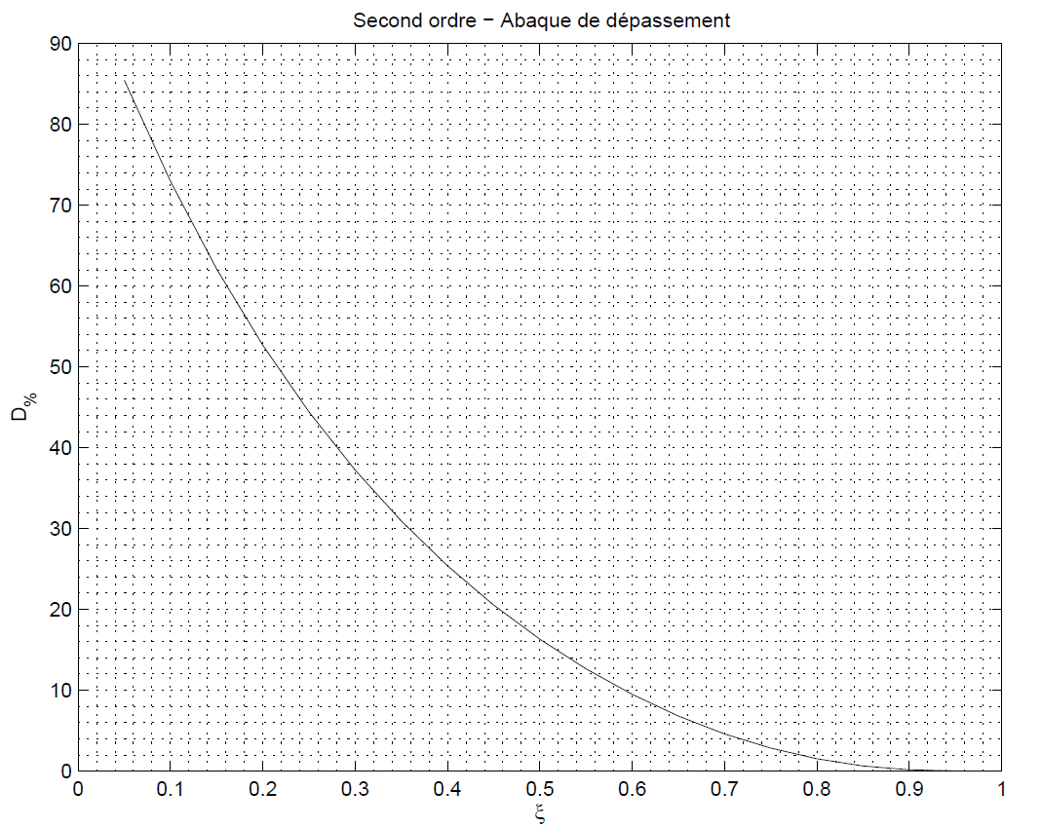
Fig 77: Overrun Abacus

Fig 78: Response time of a second order system as a function of damping

Annex 7: Characterization of DC motor with a gear ratio of 10:1

